Database Design and Implementation of a Secure Online Shopping System

Brandon Russell, Joshua Oluwadamilare, Roha Seyoum, Tinuola Okusanya

University of Maryland University College

Group 3 Project Part 1: DBST670

Professor: Selwyn Igwe

March 24, 2019

Table of Contents

Abstract 5

Statement of Work 6

Project Overview 6

Purpose and Benefits 6

Project Scope 7

Hardware and Software Specifications - Deployment 7

DDL, DML, and DCL 7

Project Work Plan 8

Team Members and Roles 8

Meeting and Communication Plan 8

Team Members Contact Information 9

Project Timeline 9

Project Schedule 9

Requirement Analysis 11

Stakeholder 11

Task Force 11

Project Description 12

Project Purpose 12

Project Scope 12

Requirements Analysis (also called Requirements Engineering). 12

Requirement Analysis Technique 13

Requirements Analysis Document 13

Functional Requirements 14

Non-functional Requirements 14

System Requirements 15

Software Requirements 15

Usability Requirements 15

Policy Requirements 15

Use Cases 15

Risks involved in Project Creation 16

Technical Risk. 16

Operational Risk. 16

Financial Risk. 16

Member Risk. 16

Customer Risk. 16

Other Risk. 16

Business Rules 17

Relationship and Cardinality among Entities 19

Keys 19

Entity Relationship Diagram (Relational) 20

Data Definition Language (DDL) Scripts 21

Drop Objects 21

Drop Tablespaces 24

Create Tables and Indexes 25

Calculations for Sizing Objects 32

Check Object Status in Catalog 35

Database Instance Creation & Sample Outputs 36

Installation Checkout Commands and Sample Output 40

Initial Backup 41

Create DBA User Script 42

Create Users 43

Alter Users Script 46

Create Tablespaces and Alter Users 46

Export and Import 48

Traditional Export / Import Example 49

Scenarios and Explanation 53

Using the Data Pump Exdp/Imdp 67

Scenarios and Explanation 68

Differences between Original Exp/Imp and Data Pump Exdp/Impdp 80

Export/Import on Secure Online Shopping System 81

SQL Control File Loaders 88

Load Data 88

Query Tables 98

Analyze Tables 103

Query Row Numbers from Catalog 107

References 108

# Abstract

In today’s fast-changing retail business continues, retailers need an increasingly subtle online shopping database management system to remain competitive. A customer will also need to buy lots of products from a shop, but it is really hard to get some time to go out and get them due to a busy lifestyle or lots of works. The traditional way of shopping requires a customer to go to a particular shop & search for products. Also, the shop from where the customer would like to buy something may not be accessible 24*7. That means customers have to adjust their time with the seller’s time. In order to overcome these, the proposed online shopping system will make life very easy for customers. A customer can search for various items and place their order from home. Unlike the traditional way of shopping that is performed physically with the effort of a person to travel & search for products, there is no need to go to the store. Online shopping system helps the customer to decrease physical work and to save time. In this case, a consumer can browse online items, compare prices, and order merchandise while they are anywhere on their computer or smartphone. The designed database helps a customer to search for products based on their inputs in an easy and suitable way. Thereafter, the user can see the product they want. Moreover, the designed database would help online retailers to reach a wider market and manage their database system in an effective and efficient way.

Database Design and Implementation of a Secure Online Shopping System

# Statement of Work

## **Project Overview**

The main objective of this group project is to design and implement for online shopping system that will store and keep track of detail information about Customer, Employee, Orders, Zip, Stores, Region, Payment, Order item, Product, and Product category. The databases will be designed in a user-friendly manner to reduces complexity and helps to manage an online shopping database system and enhance the processing efficiency.

## **Purpose and Benefits**

The database for the online shopping system is a collection of information and systematically stored in tables in the form of rows and columns. The tables in the database have a unique name that identifies their contents. The main objective of this project is to provide a user-friendly database that will be used to manage large bodies of information. This database allows a customer/ user such as to view different available products and also to place an order (purchase products) online. Furthermore, it will provide easy access to retail managers and administrators to keep track of orders for its inventory and to see orders placed. The database system must record information effectively. The system must update the available quantity of the product. Also, an employee of a virtual store can process orders and ship orders to the customer based on an order placed by sending a confirmation email. This database will also keep track of the orders that was signed off by the employee and it provides order tracking for customers. The customer will also be able to see when their item was shipped and delivered for them.

## **Project Scope**

The online shopping system will be used to retrieve, manage, and store information in a secure way. The intention of the system is to increase the efficiency of the operation within a virtual shopping store. This system can be implemented to any virtual shop and recommends a facility to receive the orders 24*7 and a home delivery system which can make customers happy.

## **Hardware and Software Specifications - Deployment**

* Data modeling software: ER Assistant and Data Modeler will be used for creating, designing, editing, and saving an ER diagram which allows seeing the structure of the created database visually and clearly, including how entities, attributes, and relationships exhibits
* Database Management System: Oracle Database 12c Enterprise Edition 12.2.0.1.0 – 64bit via AWS will be used for connecting to the database and for running the SQL statement (queries) and SQL scripts. These will be accessed from a personal computing device
* Database Development Environment: Oracle SQL Developer
* The DDL and DML will be written in SQL and imported using SQL*Loader 12.2.0.1.0

## **DDL, DML, and DCL**

Structured Query Language (SQL) will be used for the data definition language (DDL) scripts and data manipulation language (DML) scripts. After running the DDL script in Oracle SQL Developer all the entities, attributes, and relationships captured in the ERD diagram will be translated into tables, columns, and indexes, which all make the database for an online shopping system. DDL script will be used either to CREATE, DROP, or ALTER. DML script will be used, either to INSERT or UPDATE SQL statements, to make a new record or update an old one. DML script will also use to SELECT a specific table in the database. Moreover, DCL script will be used to GRANT which mainly deals with the rights, permissions, and other controls of the database security system at different levels. All scripts will be created using SQL and run using SQLPlus via Putty.

# Project Work Plan

## **Team Members and Roles**

The online shopping database development staff as shown in the following table.

|  |  |
| --- | --- |
| **Group Member** | **Team Member Role** |
| Roha Seyoum | Project Manager/DBA |
| Brandon Russell | Developer/ Data Modeler/Team Lead |
| Joshua Oluwadamilare | DBA / Business Analyst |
| Tinuola Okusanya | Business Analyst/DBA |

The project manager is responsible for preparing and layout a project schedule (timeline). The business analyst will establish the database system requirements based on the business user and the stakeholder's needs. The developer will develop the SQL script. The Data Modeler will design the ER diagram. The DBA will develop and implement the designed database.

## **Meeting and Communication Plan**

Weekly Meeting Schedule – Sunday @ 3 PM EST via WhatsApp. The group meeting will be set up by the project manager. Additional communication was performed using group discussion board and personal email. The Project manager posted an online chat conversation in the group locker for reference.

## **Team Members Contact Information**

|  |  |  |
| --- | --- | --- |
| **Group Member Name** | **Telephone Numbers** | **Email Address** |
| Brandon Russell | 678-435-1858 | [rbrandon87@gmail.com](mailto:rbrandon87@gmail.com) |
| Joshua Oluwadamilare | 240-615-3833 | [joluwadamilare@student.umuc.edu](mailto:joluwadamilare@student.umuc.edu) |
| Roha Seyoum | 202-644-6966 | |  |  | | --- | --- | |  | [rseyoum@student.umuc.edu](mailto:rseyoum@student.umuc.edu) | |
| Tinuola Okusanya | 410-599-2379 | [okusanya@student.umuc.edu](mailto:tokusanya@student.umuc.edu) |

## **Project Timeline**

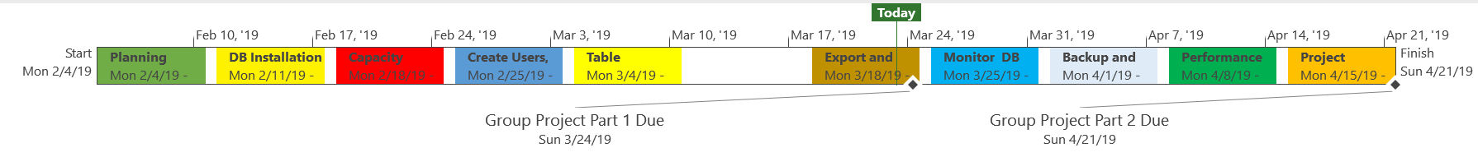

The above project timeline identifies the allocated time for completion of each task.

## **Project Schedule**

Below is the project schedule that identifies the schedule of tasks and who will be responsible for completion. This Gantt chart shows the timeline for each milestone, task, the names of the project resources assigned to each task and the proposed start and end date for the entire project. For this project, each task will be worked on sequentially. The end of each milestone marks a true success in our project and ensures that every task in the project is completed on time with great quality.

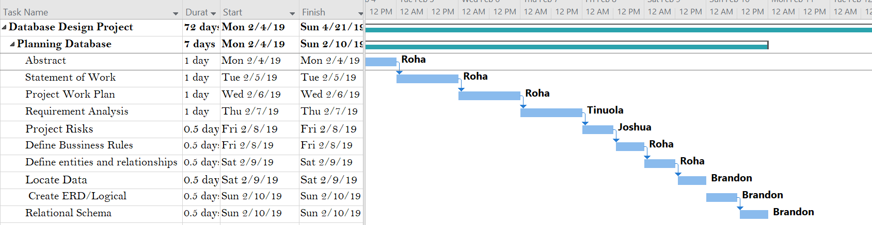

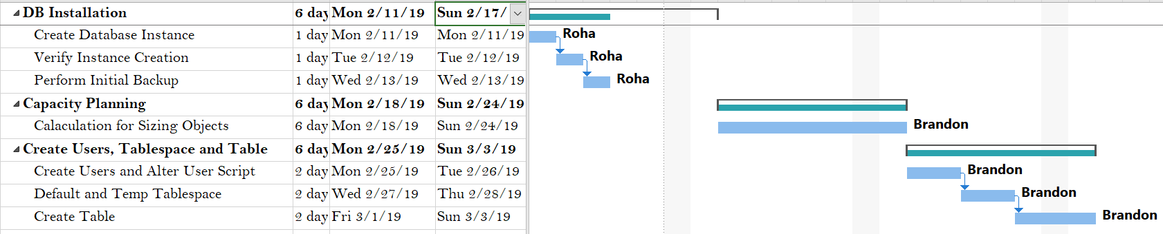

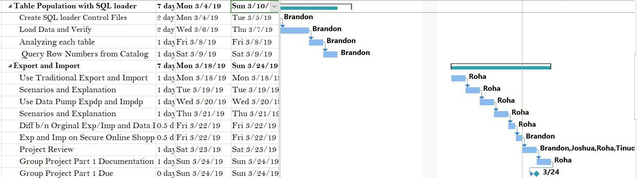

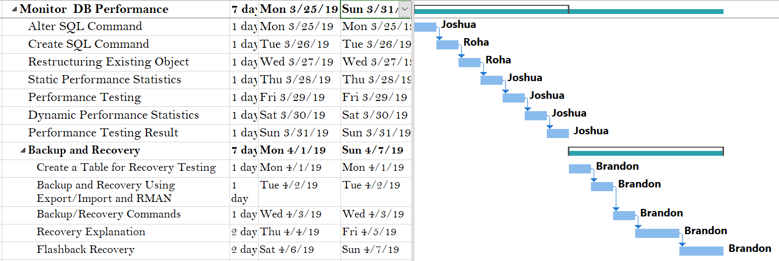

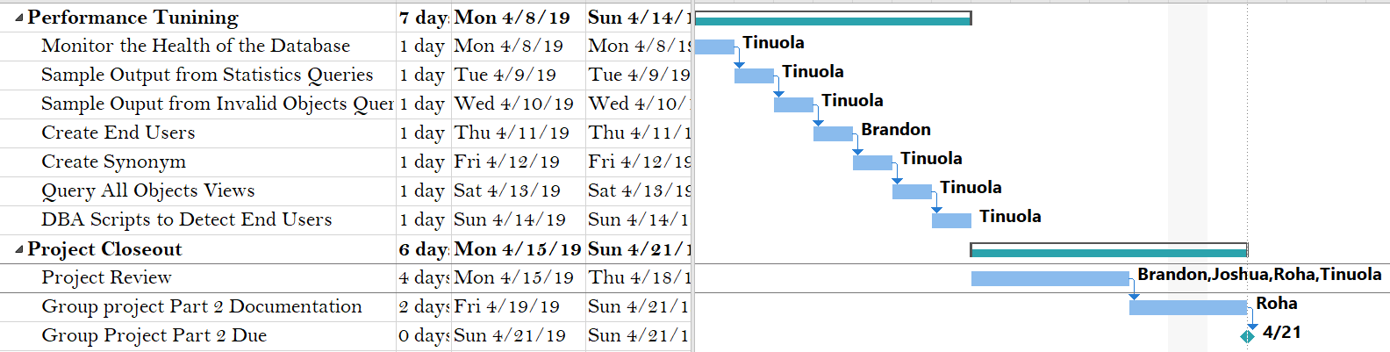

# Requirement Analysis

## **Stakeholder**

This is the project owner that made a request for a database to administer and manage their business.

## **Task Force**

Project team users, i.e. Project manager, System designer, Database Developer, Business analyst, Database Modeler and Database administrator, and management.

## **Project Description**

An online shopping database system.

## **Project Purpose**

The online shopping database system is required to store, retrieve, and manage the organization business transactions. The database will be utilized for keeping employee and daily records of transactional sales of the organization in relation to Customer, Orders, Zip, Stores, Region, Payment, Order item, Product, and Product category. The online database will aid and improve accountability, communication, and customer relationship. Employees, customers, products, stores, orders, and payments records will be traceable and can be connected to derive useful information about them. Also, the information in the database can be employed to determine sales promotion, frequently purchase items, customer reward programs, employee appreciation and business improvement as needed. The database will be a storage of information for now and for future reference.

## **Project Scope**

This project will deal with system design, software installation, testing, and implementation. Once the project is completed the database will enter the maintenance cycle.

Requirements Elicitation. Done by asking what the requirements are, what if this, what if that, from stakeholder. Various questions are asked for clarification of purpose and responses are derived. These require the stakeholders to answer their part of what is to be done? and why? by the project team.

## **Requirements Analysis (also called Requirements Engineering).**

The process of determining user expectations for a new or modified product (Rouse, 2019). Joint application development (JAD) is applied in this project requirement analysis. JAD allows the project team, users, and management to work together to identify the actual system’s requirements. In additional questionnaires are used to collect information from customers so the database can fulfill customer satisfaction.

## **Requirement Analysis Technique**

Used to map the business workflow to analyze, understand and make required changes to that workflow or process (Requirements Analysis Techniques with Example: Complete Tutorial, 2019). The requirement analyzing techniques that are used for this software development process is Business process modeling notation (BPMN). This is a graphical representation of the business process using simple objects, which helps the organization to communicate in a standard manner. This model gives detail about the activities carried out during the process by the working group weekly. The working group is active during the week and meet every Sunday by 3 p.m. on WhatsApp to check the status of the project and send current issue list to solve before the next meeting.

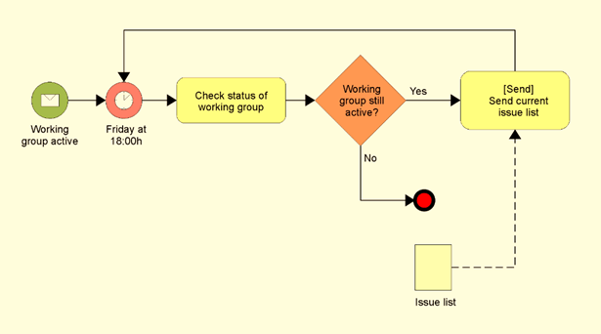

## **Requirements Analysis Document**

The results of the requirements elicitation and the analysis activities are documented in the Requirements Analysis Document (RAD). This document completely describes the system in terms of functional and nonfunctional requirements and serves as a contractual basis between the stakeholders and the developer.

## **Functional Requirements**

Necessary attributes in a system that specifies what the system or one of its products must do:

* The user must have access to database i.e. view product item and purchase
* Users can communicate to the organization through database i.e. make a purchase online, send a message.
* Users access can be through creating an account or purchase as a guess.
* Users can cancel or change orders.
* Users must be able to pay for items in the database.
* Only the database administrator can manage the database.
* Business can send order status and received payment notification.

## **Non-functional Requirements**

Criteria that can be used to judge the operation of a system, rather than specific behaviors. They serve as constraints or restrictions on the design of the system across the different backlogs. They are defined system attributes such as:

* Security, reliability, performance, maintainability, scalability, and usability.
* Physical environment (equipment locations, multiple sites, etc.).
* Interfaces (data medium etc.).
* User & human factors (who are the users, their skill level etc.).

## **System Requirements**

Chrome versions 45 or higher Firefox Version 48, 64bit operating system, 2.50 GHz of CPU and at least 12GB of RAM.

## **Software Requirements**

Oracle database 12c Enterprise Edition Release 12.2.0.1.0 - 64 bits, Oracle Modeler, Entity Relation Diagram, (ERD), Putty and FileZilla.

## **Usability Requirements**

User task performance, user satisfaction, learnability, memorability:

* The online database system will function in major browsers to ease access by customers.
* It will support mobile users.
* Simple interface that is easy to learn how to use and easy to remember how to use.

## **Policy Requirements**

* System functions will be driven by policy whenever possible (Government, Access control and security beach policies).
* Same policies apply online and in stores for purchase.
* Only the database administrator has sysdba privilege to administer and manage the database.

## **Use Cases**

According to (Maxim, 2012), use cases are documents that describe how the product will be used in specific situations. It can be in the form of written narratives that describe the role of a user or device as it interacts with the system. A use case is a technique for documenting the potential requirements of a new system or software change (Sofia, 2010). Use-cases are designed from the users’ point of view. Not all users can be identified during the first iteration of requirements elicitation, but it is important to identify the primary users before developing the use- cases.

## **Risks involved in Project Creation**

The following risks may affect the project:

**Technical Risk.** Unauthorized personnel may gain access to the system where they may violate data confidentiality, integrity, and availability which can affect system security.

**Operational Risk.** Operational risk is the failure of information not being delivered on time. This can be due to the project failing to be delivered on time due to poor or lack of senior management support hence delaying in the decision-making processes which may delay the project. The project may also fail to be delivered on time due to lack of standardized project management methodologies which may lead to improper management of the system.

**Financial Risk.** The project may be at a risk if not being delivered within the planned budget. In this case, the project is at risk of not being completed within the allocated budget for the project.

**Member Risk.** The project may be at risk of the project team not meeting the requirements of the user. The requirements may not be met either by having a team who may not have adequate knowledge about software development (Barbradozier, 2013). The project procurement team may purchase substandard materials that are not of high quality as the project sponsor expected it. Also, the project may be at risk of not meeting the clients’ requirements due to poor participation in the development process.

**Customer Risk.** The project may be at risk of the customer changing the project requirements.

**Other Risk.** If the staff are not well skilled and not committed to the project, it can become a risk.

# Business Rules

Business rules for a database are brief descriptions of policies that define what and how the data and information in a database are entered, stored, and processed. The online shopping database system consists of ten major entities; Customer, Employee, Orders, Zip, Stores, Region, Payment, Order item, Product, and Product category. Business rules are put into place during the design phase of a database system. Some of the business rules are as follows:

1. **Customer and Zip:**

* A customer has one and only one zip. Each zip belongs to zero or many customers.

1. **Customer and Orders:**

* A customer can place one or many orders. Each order belongs to one and only one customer.

1. **Payment and Orders:**

* Each order has one or more payment. A payment belongs to one and only one order

1. **Order and Order_Time:**

* An order can have one or more items. Each item belongs to one and only one order

1. **Order_Item and Product:**

* Each order item belongs to one and only one product. A product has zero or more items

1. **Employee and Orders:**

* An employee can place zero or many orders. Each order must be placed by one and only one employee

1. **Employee and Stores:**

* An employee is assigned to only one store. Each store has zero or many employees

1. **Regions and Stores:**

* A region has zero or more stores. Each store belongs to one and only one region

1. **Product and Product_Cat:**

* A product can only belong to one category. Each category has zero or more products

1. **Employee and Zip:**

* An employee can only belong to one zip. Each zip is assigned for zero or many employees

1. **Stores and Zip:**

* A store has one and only one zip. Each zip belongs to zero or many stores

These are some of the basic business rules that we should implement to design a database. These business rules control the relationships and constraints of the database. Business rules also must be updated on time to stay aware of the operational condition of the business. There must be a good relationship among the major entities. The creation of the logical data model is key to understanding how the rest of the design process will work. A physical database model (relational schema) shows all table structures, including *column name, column data type, column constraints, primary key, foreign key,* and *relationships* between tables. Features of a physical data model include:

* Specification of all tables and columns.
* Foreign keys are used to identify relationships between tables.

The steps for physical data model design are as follows:

-Convert entities into tables.

* Convert relationships into foreign keys.
* Convert attributes into columns.
* Modify the physical data model based on physical constraints/requirements.

## **Relationship and Cardinality among Entities**

The following association exists between entities:

* customer and orders: *zero or one to many* relationship
* customer and zip: *one and only one to zero or many* relationship
* orders and payment: *one or many to only one* relationship
* orders and orders item: *one or many to only one* relationship
* order item and product: *only* *one to zero or many* relationship
* Product and product category: *one and only one to zero or many* relationship
* Stores and region: *one and only one to zero or many* relationship
* Employee and stores: *one and only one to zero or many* relationship
* Employee and orders: *zero or many to one and only one* relationship
* Employee and zip: *one and only one to zero or many* relationship
* Zip and stores: *zero or many to one and only one* relationship

## **Keys**

* The primary key for the *customer table* would be the CUSTOMERID
* The primary key for the *orders table* would be ORDERID. The foreign keys for this table would be CUSTMERID and SALES_EMP_SS.
* The primary key for the *payment table* would be PAYMENTID. The foreign keys for this table would be ORDERID.
* The primary key for the *order item* *table* would be ORDERID. ORDERID and PRODUCTID would be composite keys.
* The primary key for the *product table* would be PRODUCTID. The foreign key for this table would be PRODCATID.
* The primary key for the *product category table* would be PRODCATID.
* The primary key for the *region table* would be REGIONID.
* The primary key for the *stores table* would be STOREID. The foreign key for this table would be ZIPCODE and REGIONID.
* The primary key for the *employee table* would be SALES_EMP_SS. The foreign key for this table would be ZIPCODE and STOREID.
* The primary key for the *zip table* would be ZIPCODE.

Therefore, these tables are related to one another through important keys. In this way, the entire online shopping database system is integrated into a single database.

# Entity Relationship Diagram (Relational)

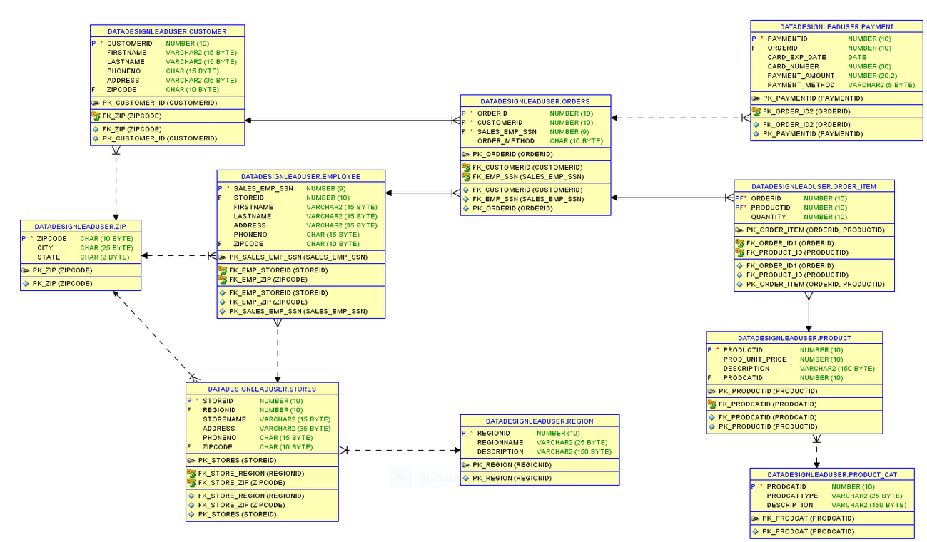

# Data Definition Language (DDL) Scripts

## **Drop Objects**

SQL> SET ECHO ON;

SQL>

SQL> SET SERVEROUTPUT ON;

SQL>

SQL> /*---------------------------------------------------*/

SQL> /* DROP OBJECTS */

SQL> /*---------------------------------------------------*/

SQL>

SQL> SHOW USER;

USER is "SYSTEM"

SQL>

SQL> CONNECT DataDesignLeadUser/abc123;

Connected.

SQL>

SQL> SHOW USER;

USER is "DATADESIGNLEADUSER"

SQL>

SQL> /*Drop Indexes*/

SQL>

SQL> DROP INDEX fk_zip;

Index FK_ZIP dropped.

SQL>

SQL> DROP INDEX fk_customerid;

Index FK_CUSTOMERID dropped.

SQL>

SQL> DROP INDEX fk_order_id1;

Index FK_ORDER_ID1 dropped.

SQL>

SQL> DROP INDEX fk_product_id;

Index FK_PRODUCT_ID dropped.

SQL>

SQL> DROP INDEX fk_order_id2;

Index FK_ORDER_ID2 dropped.

SQL>

SQL> DROP INDEX fk_emp_storeid;

Index FK_EMP_STOREID dropped.

SQL>

SQL> DROP INDEX fk_emp_zip;

Index FK_EMP_ZIP dropped.

SQL>

SQL> DROP INDEX fk_store_region;

Index FK_STORE_REGION dropped.

SQL>

SQL> DROP INDEX fk_store_zip;

Index FK_STORE_ZIP dropped.

SQL>

SQL> DROP INDEX fk_prodcatid;

Index FK_PRODCATID dropped.

SQL>

SQL> DROP INDEX fk_emp_ssn;

Index FK_EMP_SSN dropped.

SQL>

SQL> /*Drop Tables*/

SQL>

SQL> DROP TABLE payment;

Table PAYMENT dropped.

SQL>

SQL> DROP TABLE order_item;

Table ORDER_ITEM dropped.

SQL>

SQL> DROP TABLE orders;

Table ORDERS dropped.

SQL>

SQL> DROP TABLE product;

Table PRODUCT dropped.

SQL>

SQL> DROP TABLE customer;

Table CUSTOMER dropped.

SQL>

SQL> DROP TABLE employee;

Table EMPLOYEE dropped.

SQL>

SQL> DROP TABLE stores;

Table STORES dropped.

SQL>

SQL> DROP TABLE zip;

Table ZIP dropped.

SQL>

SQL> DROP TABLE region;

Table REGION dropped.

SQL>

SQL> DROP TABLE product_cat;

Table PRODUCT_CAT dropped.

SQL>

SQL>

SQL> /*Disconnect DataDesignLeadUser, Login as system to drop users and create other objects*/

SQL>

SQL> DISCONNECT;

Disconnected from Oracle Database 12c Enterprise Edition Release 12.2.0.1.0 - 64bit Production

SQL>

## **Drop Tablespaces**

SQL>

SQL> /*DROP TABLESPACES*/

SQL>

SQL> DROP TABLESPACE "USER_DATA1" INCLUDING CONTENTS;

TABLESPACE "USER_DATA1" dropped.

SQL>

SQL> DROP TABLESPACE "USER_DATA2" INCLUDING CONTENTS;

TABLESPACE "USER_DATA2" dropped.

SQL>

SQL> DROP TABLESPACE "USER_INDX1" INCLUDING CONTENTS;

TABLESPACE "USER_INDX1" dropped.

SQL>

SQL> DROP TABLESPACE "USER_TEMP" INCLUDING CONTENTS;

TABLESPACE "USER_TEMP" dropped.

## **Create Tables and Indexes**

SQL>

SQL> /*---------------------------------------------------*/

SQL> /* CREATE TABLES */

SQL> /*---------------------------------------------------*/

SQL>

SQL> CREATE TABLE zip (

2 zipcode CHAR(10) NOT NULL,

3 city CHAR(25),

4 state CHAR(2),

5 CONSTRAINT pk_zip PRIMARY KEY ( zipcode )

6 USING INDEX TABLESPACE user_indx1

7 STORAGE ( INITIAL 1000 K NEXT 120 K )

8 )

9 PARTITION BY RANGE (

10 state

11 )

12 ( PARTITION zip_part1

13 VALUES LESS THAN ( 'N' )

14 PCTFREE 5 PCTUSED 90 TABLESPACE user_data1

15 STORAGE ( INITIAL 1092 k NEXT 200 k MAXEXTENTS UNLIMITED PCTINCREASE 0 ),

16 PARTITION zip_part2

17 VALUES LESS THAN ( MAXVALUE )

18 PCTFREE 5 PCTUSED 90 TABLESPACE user_data2

19 STORAGE ( INITIAL 1092 k NEXT 200 k MAXEXTENTS UNLIMITED PCTINCREASE 0 )

20 );

Table ZIP created.

SQL>

SQL> CREATE TABLE customer (

2 customerid NUMBER(10) NOT NULL,

3 firstname VARCHAR2(15),

4 lastname VARCHAR2(15),

5 phoneno CHAR(15),

6 address VARCHAR2(35),

7 zipcode CHAR(10),

8 CONSTRAINT pk_customer_id PRIMARY KEY ( customerid )

9 USING INDEX TABLESPACE user_indx1

10 STORAGE ( INITIAL 50 K NEXT 10 K ),

11 CONSTRAINT fk_zip FOREIGN KEY ( zipcode )

12 REFERENCES zip

13 )

14 PCTFREE 20 PCTUSED 40 TABLESPACE user_data1

15 STORAGE ( INITIAL 120 k NEXT 10 k MAXEXTENTS UNLIMITED PCTINCREASE 0 );

Table CUSTOMER created.

SQL>

SQL> CREATE TABLE product (

2 productid NUMBER(10) NOT NULL,

3 prod_unit_price NUMBER(10),

4 description VARCHAR2(150),

5 CONSTRAINT pk_productid PRIMARY KEY ( productid )

6 USING INDEX TABLESPACE user_indx1

7 STORAGE ( INITIAL 50 K NEXT 10 K )

8 )

9 PCTFREE 5 PCTUSED 90 TABLESPACE user_data2

10 STORAGE ( INITIAL 168 k NEXT 20 k MAXEXTENTS UNLIMITED PCTINCREASE 0 );

Table PRODUCT created.

SQL>

SQL> CREATE TABLE region (

2 regionid NUMBER(10) NOT NULL,

3 regionname VARCHAR(25),

4 description VARCHAR(150),

5 CONSTRAINT pk_region PRIMARY KEY ( regionid )

6 USING INDEX TABLESPACE user_indx1

7 STORAGE ( INITIAL 50 K NEXT 10 K )

8 )

9 PCTFREE 5 PCTUSED 90 TABLESPACE user_data1

10 STORAGE ( INITIAL 192 k NEXT 20 k MAXEXTENTS UNLIMITED PCTINCREASE 0 );

Table REGION created.

SQL>

SQL> CREATE TABLE stores (

2 storeid NUMBER(10) NOT NULL,

3 regionid NUMBER(10),

4 storename VARCHAR2(15),

5 address VARCHAR2(35),

6 phoneno CHAR(15),

7 zipcode CHAR(10),

8 CONSTRAINT pk_stores PRIMARY KEY ( storeid )

9 USING INDEX TABLESPACE user_indx1

10 STORAGE ( INITIAL 50 K NEXT 10 K ),

11 CONSTRAINT fk_store_region FOREIGN KEY ( regionid )

12 REFERENCES region,

13 CONSTRAINT fk_store_zip FOREIGN KEY ( zipcode )

14 REFERENCES zip

15 )

16 PCTFREE 5 PCTUSED 90 TABLESPACE user_data1

17 STORAGE ( INITIAL 96 k NEXT 10 k MAXEXTENTS UNLIMITED PCTINCREASE 0 );

Table STORES created.

SQL>

SQL> CREATE TABLE employee (

2 sales_emp_ssn NUMBER(9) NOT NULL,

3 storeid NUMBER(10),

4 firstname VARCHAR2(15),

5 lastname VARCHAR2(15),

6 address VARCHAR2(35),

7 phoneno CHAR(15),

8 zipcode CHAR(10),

9 CONSTRAINT pk_sales_emp_ssn PRIMARY KEY ( sales_emp_ssn )

10 USING INDEX TABLESPACE user_indx1

11 STORAGE ( INITIAL 50 K NEXT 10 K ),

12 CONSTRAINT fk_emp_storeid FOREIGN KEY ( storeid )

13 REFERENCES stores,

14 CONSTRAINT fk_emp_zip FOREIGN KEY ( zipcode )

15 REFERENCES zip

16 )

17 PCTFREE 20 PCTUSED 40 TABLESPACE user_data1

18 STORAGE ( INITIAL 120 k NEXT 10 k MAXEXTENTS UNLIMITED PCTINCREASE 0 );

Table EMPLOYEE created.

SQL>

SQL> CREATE TABLE orders (

2 orderid NUMBER(10) NOT NULL,

3 customerid NUMBER(10) NOT NULL,

4 sales_emp_ssn NUMBER(9) NOT NULL,

5 order_method CHAR(10),

6 CONSTRAINT pk_orderid PRIMARY KEY ( orderid )

7 USING INDEX TABLESPACE user_indx1

8 STORAGE ( INITIAL 50 K NEXT 10 K ),

9 CONSTRAINT fk_customerid FOREIGN KEY ( customerid )

10 REFERENCES customer,

11 CONSTRAINT fk_emp_ssn FOREIGN KEY ( sales_emp_ssn )

12 REFERENCES employee

13 )

14 PCTFREE 5 PCTUSED 60 TABLESPACE user_data1

15 STORAGE ( INITIAL 24 k NEXT 10 k MAXEXTENTS UNLIMITED PCTINCREASE 0 );

Table ORDERS created.

SQL>

SQL> CREATE TABLE order_item (

2 orderid NUMBER(10) NOT NULL,

3 productid NUMBER(10),

4 quantity NUMBER(10),

5 CONSTRAINT pk_order_item PRIMARY KEY ( orderid,

6 productid )

7 USING INDEX TABLESPACE user_indx1

8 STORAGE ( INITIAL 50 K NEXT 10 K ),

9 CONSTRAINT fk_order_id1 FOREIGN KEY ( orderid )

10 REFERENCES orders,

11 CONSTRAINT fk_product_id FOREIGN KEY ( productid )

12 REFERENCES product

13 )

14 PCTFREE 5 PCTUSED 90 TABLESPACE user_data2

15 STORAGE ( INITIAL 16 k NEXT 20 k MAXEXTENTS UNLIMITED PCTINCREASE 0 );

Table ORDER_ITEM created.

SQL>

SQL> CREATE TABLE payment (

2 paymentid NUMBER(10) NOT NULL,

3 orderid NUMBER(10),

4 card_exp_date DATE,

5 card_number NUMBER(30),

6 payment_amount NUMBER(20,2),

7 payment_method VARCHAR2(5),

8 CONSTRAINT pk_paymentid PRIMARY KEY ( paymentid )

9 USING INDEX TABLESPACE user_indx1

10 STORAGE ( INITIAL 50 K NEXT 10 K ),

11 CONSTRAINT fk_order_id2 FOREIGN KEY ( orderid )

12 REFERENCES orders

13 )

14 PCTFREE 20 PCTUSED 40 TABLESPACE user_data2

15 STORAGE ( INITIAL 40 k NEXT 10 k MAXEXTENTS UNLIMITED PCTINCREASE 0 );

Table PAYMENT created.

SQL>

SQL>

SQL> CREATE TABLE product_cat (

2 prodcatid NUMBER(10) NOT NULL,

3 prodcattype VARCHAR(25),

4 description VARCHAR(150),

5 CONSTRAINT pk_prodcat PRIMARY KEY ( prodcatid )

6 USING INDEX TABLESPACE user_indx1

7 STORAGE ( INITIAL 50 K NEXT 10 K )

8 )

9 PCTFREE 5 PCTUSED 90 TABLESPACE user_data1

10 STORAGE ( INITIAL 192 k NEXT 20 k MAXEXTENTS UNLIMITED PCTINCREASE 0 );

Table PRODUCT_CAT created.

SQL>

SQL>

SQL> /*Alter Product table to include additional Product Category ID*/

SQL> ALTER TABLE PRODUCT ADD PRODCATID NUMBER (10)

2 CONSTRAINT fk_prodcatid references PRODUCT_CAT(PRODCATID);

Table PRODUCT altered.

SQL>

SQL>

SQL> /*--------------------------------------------*/

SQL> /* INDEXES */

SQL> /*--------------------------------------------*/

SQL> CREATE INDEX fk_zip ON

2 customer (

3 zipcode

4 )

5 TABLESPACE user_indx1

6 STORAGE ( INITIAL 50 K NEXT 10 K );

Index FK_ZIP created.

SQL>

SQL> CREATE INDEX fk_customerid ON

2 orders (

3 customerid

4 )

5 TABLESPACE user_indx1

6 STORAGE ( INITIAL 50 K NEXT 10 K );

Index FK_CUSTOMERID created.

SQL>

SQL> CREATE INDEX fk_order_id1 ON

2 order_item (

3 orderid

4 )

5 TABLESPACE user_indx1

6 STORAGE ( INITIAL 50 K NEXT 10 K );

Index FK_ORDER_ID1 created.

SQL>

SQL> CREATE INDEX fk_product_id ON

2 order_item (

3 productid

4 )

5 TABLESPACE user_indx1

6 STORAGE ( INITIAL 50 K NEXT 10 K );

Index FK_PRODUCT_ID created.

SQL>

SQL> CREATE INDEX fk_order_id2 ON

2 payment (

3 orderid

4 )

5 TABLESPACE user_indx1

6 STORAGE ( INITIAL 50 K NEXT 10 K );

Index FK_ORDER_ID2 created.

SQL>

SQL> CREATE INDEX fk_emp_storeid ON

2 employee (

3 storeid

4 )

5 TABLESPACE user_indx1

6 STORAGE ( INITIAL 50 K NEXT 10 K );

Index FK_EMP_STOREID created.

SQL>

SQL> CREATE INDEX fk_emp_zip ON

2 employee (

3 zipcode

4 )

5 TABLESPACE user_indx1

6 STORAGE ( INITIAL 50 K NEXT 10 K );

Index FK_EMP_ZIP created.

SQL>

SQL> CREATE INDEX fk_store_region ON

2 stores (

3 regionid

4 )

5 TABLESPACE user_indx1

6 STORAGE ( INITIAL 50 K NEXT 10 K );

Index FK_STORE_REGION created.

SQL>

SQL> CREATE INDEX fk_store_zip ON

2 stores (

3 zipcode

4 )

5 TABLESPACE user_indx1

6 STORAGE ( INITIAL 50 K NEXT 10 K );

Index FK_STORE_ZIP created.

SQL>

SQL> CREATE INDEX fk_prodcatid ON

2 product (

3 prodcatid

4 )

5 TABLESPACE user_indx1

6 STORAGE ( INITIAL 50 K NEXT 10 K );

Index FK_PRODCATID created.

SQL>

SQL> CREATE INDEX fk_emp_ssn ON

2 orders (

3 sales_emp_ssn

4 )

5 TABLESPACE user_indx1

6 STORAGE ( INITIAL 50 K NEXT 10 K );

Index FK_EMP_SSN created.

# Calculations for Sizing Objects

UserData 1 = 2184K + 120K + 100K+120K+96K+192K+192K = 3,004K

UserData 2 = 2184K + 168K + 16K+40K = 2,408K

|  |  |  |  |  |  |  |
| --- | --- | --- | --- | --- | --- | --- |
| Zip 5/90  _______  2476K - Split in User_Data1&2  Zipcode = 10 Varchar  City = 25 Varchar  State = 2 Char  data space = (8108 - 2*R) - ((8108 - 2*R) * 5/100)  data space = (8108 - 2*R) - (405.4 - .1*R)  data space = 8108 - 2*R - 405.4 + .1*R  data space = 7702.6 - 1.9*R  Total Bytes = 40  7702.6 - 1.9*R/ 40  192.57 - 0.048R  1.048R = 192.57  R = 183.75  ceiling(50000/183.75) = ceiling(273)  273*8K blocks  = 2184K | | Customer Size 20/40  -----  120K - User_Data1  CUSTOMERID = Integer = log(500)/Log(2)/8 = 1  Firstname = 15 varchar  Lastname = 15 varchar  phoneno = 15 char  address = 35 varchar  zipcode 10 char  data space = (8108 - 2*R) - ((8108 - 2*R) * 20/100)  data space = (8108 - 2*R) - (1621.6 - .4*R)  data space = 8108 - 2*R - 1621.6 + .4*R  data space = 6486.4 - 1.6*R  Total Bytes = 94  6486.4 - 1.6*R/ 94  69 - 0.017R  1.017R = 69  R = 67.85  ceiling(1000/67.85) = ceiling(15)  15*8K blocks  = 120 Kilobytes | | | Orders 5/60  -----  100K - User_Data1  OrderID = Integer = log(500)/Log(2)/8 = 1  CustomerId = Integer = log(500)/Log(2)/8 = 1  Sales_emp_ssn = Integer log(199,606,147)/log(2)/8 = 4  Order_Method = 10 char  data space = (8108 - 2*R) - ((8108 - 2*R) * 5/100)  data space = (8108 - 2*R) - (405.4 - .1*R)  data space = 8108 - 2*R - 405.4 + .1*R  data space = 7702.6 - 1.9*R  Total Bytes = 19  7702.6 - 1.9*R/ 19  405.4 - 0.001R  1.001R = 405.4  R = 405  ceiling(1000/405) = ceiling(3)  3*8K blocks  = 24K kilobytes | |
| Product 5/90  ----  150K - User_Data2  ProductId = Integer = Log(7000)/Log(2)/8 = 2  Prod_Unit_Price = Log(80)/Log(2)/8 = 1  Description = 150 varchar  data space = (8108 - 2*R) - ((8108 - 2*R) * 5/100)  data space = (8108 - 2*R) - (405.4 - .1*R)  data space = 8108 - 2*R - 405.4 + .1*R  data space = 7702.6 - 1.9*R  Total Bytes = 156  7702.6 - 1.9*R/ 156  49.38 - 0.01R  1.010R = 49.38  R = 48.89  ceiling(1000/49) = ceiling(21)  21*8K blocks  = 168 Kilobytes | Order_Item 5/90  ------  50K - User_Data2  Orderid = Integer = log(500)/Log(2)/8 = 1  ProductID = Integer = log(500)/Log(2)/8 = 1  Quantity = Integer = log(2)/Log(2)/8 = 1  data space = (8108 - 2*R) - ((8108 - 2*R) * 5/100)  data space = (8108 - 2*R) - (405.4 - .1*R)  data space = 8108 - 2*R - 405.4 + .1*R  data space = 7702.6 - 1.9*R  Total Bytes = 6  7702.6 - 1.9*R/ 6  1283.77 - 0.32R  1.31R = 1283.77  R = 979.98  ceiling(1000/980) = ceiling(2)  2*8K blocks  = 16 Kilobytes | | | Payment 20/40  -----  100K - User_Data 2  PaymentId = Integer = log(500)/Log(2)/8 = 1  OrderID = Integer = log(500)/Log(2)/8 = 1  Car_Exp_Date = date = 7  card_number = Integer = log(1851851849647260)/log(2)/8 = 7  payment_amount = Integer = Log(80)/Log(2)/8 = 1  payment_method = 5 varchar  data space = (8108 - 2*R) - ((8108 - 2*R) * 20/100)  data space = (8108 - 2*R) - (1621.6 - .4*R)  data space = 8108 - 2*R - 1621.6 + .4*R  data space = 6486.4 - 1.6*R  Total Bytes = 25  6486.4 - 1.6*R/ 25  259.46 - 0.064R  1.064R = 259.46  R = 243.9  ceiling(1000/243.9) = ceiling(5)  5*8K blocks  = 40 Kilobytes | | |
| Employee – UserData1  -------  20/40...like Customer table  Address = 35 Varchar  Firstname = 15 Varchar  Lastname = 15 Varchar  PhoneNo = 15 Varchar  Sales_emp_ssn = Integer = log(199,606,147)/log(2)/8 = 4  storeid - Integer = avg(500) = 1  zipcode = char 5  ---  data space = (8108 - 2*R) - ((8108 - 2*R) * 20/100)  data space = (8108 - 2*R) - (1621.6 - .4*R)  data space = 8108 - 2*R - 1621.6 + .4*R  data space = 6486.4 - 1.6*R  Total Bytes = 93  6486.4 - 1.6*R/ 93  69.74 - 0.017R  1.017R = 69.74  R = 68.57  ceiling(1000/15) = ceiling(15)  15*8K blocks  = 120 Kilobytes | | | Store – UserData1  -----  5/90  Address = 35  phoneno= 15  regionid = int = avg(500) = 1  storename =varchar 25  zipcode = char 5  data space = (8108 - 2*R) - ((8108 - 2*R) * 5/100)  data space = (8108 - 2*R) - (405.4 - .1*R)  data space = 8108 - 2*R - 405.4 + .1*R  data space = 7702.6 - 1.9*R  Total Bytes = 84  7702.6 - 1.9*R/ 84  91.7 - 0.022R  1.022R = 91.7  R = 89.72  ceiling(1000/90) = ceiling(12)  12*8K blocks  = 96K kilobytes | | | Region – UserData1  ------  5/90  description = varchar 150  regionid = int = avg(500) = 1  regionname = varchar 25  data space = (8108 - 2*R) - ((8108 - 2*R) * 5/100)  data space = (8108 - 2*R) - (405.4 - .1*R)  data space = 8108 - 2*R - 405.4 + .1*R  data space = 7702.6 - 1.9*R  Total Bytes = 179  7702.6 - 1.9*R/ 179  43.03 - 0.01R  1.010R = 43.03  R = 42.6  ceiling(1000/43) = ceiling(24)  12*8K blocks  = 192 Kilobytes |
| ProdCat – UserData1  ------  5/90  description = varchar 150  prodcatid = int = avg(500) = 1  prodcattype = varchar 25  data space = (8108 - 2*R) - ((8108 - 2*R) * 5/100)  data space = (8108 - 2*R) - (405.4 - .1*R)  data space = 8108 - 2*R - 405.4 + .1*R  data space = 7702.6 - 1.9*R  Total Bytes = 179  7702.6 - 1.9*R/ 179  43.03 - 0.01R  1.010R = 43.03  R = 42.6  ceiling(1000/43) = ceiling(24)  12*8K blocks  = 192 Kilobytes | | | | | | |

# Check Object Status in Catalog

SQL>

SQL> /*---------------------------------------------*/

SQL> /* CHECK CONTENT OF CATALOG */

SQL> /*---------------------------------------------*/

SQL>

SQL> /*Show valid status from all objects*/

SQL> SELECT

2 substr

3 (object_name,1,20),

4 object_type,status FROM

5 user_objects;

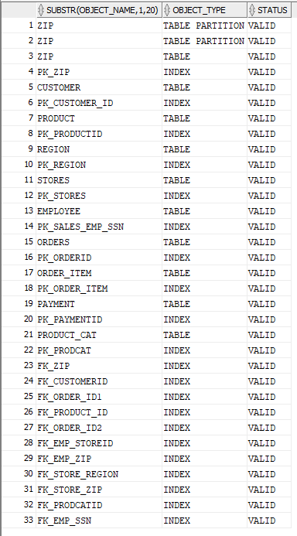

# Database Instance Creation & Sample Outputs

Below are sample screenshots that show the creation of an Oracle database 12c instance in the remote server from the AWS based on the document “Oracle Database 12.2.0 Installation Step by Step using oracle utility dbca.docx” provided. This section also contains a screenshot that shows the installation test and the initial backup of the database.

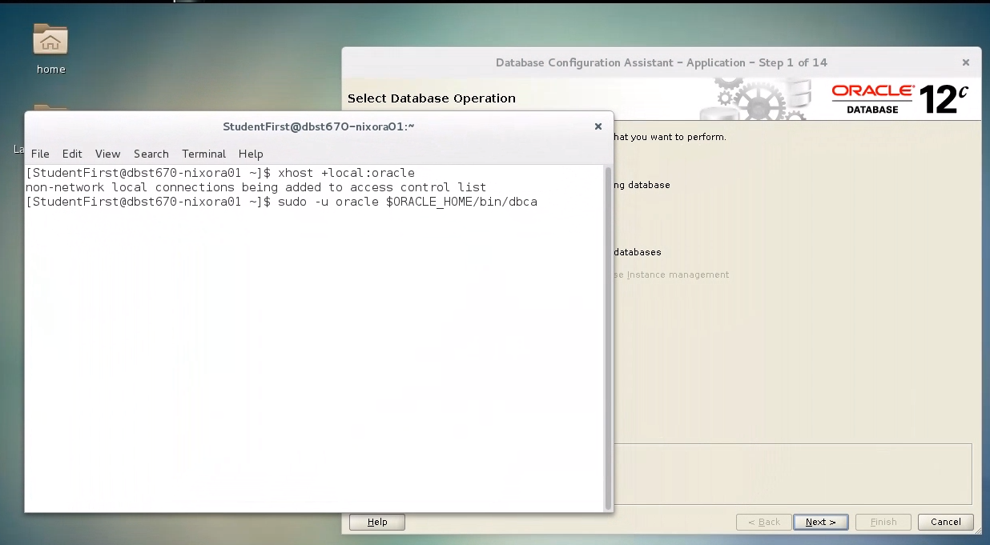

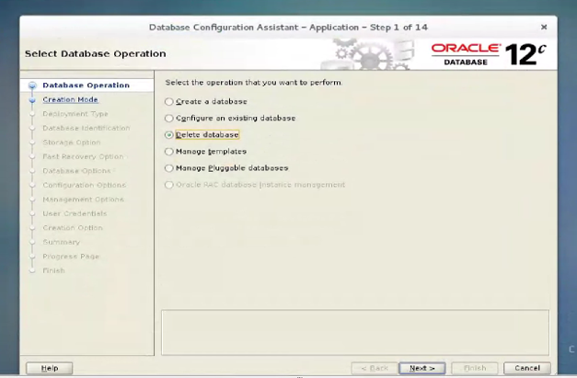

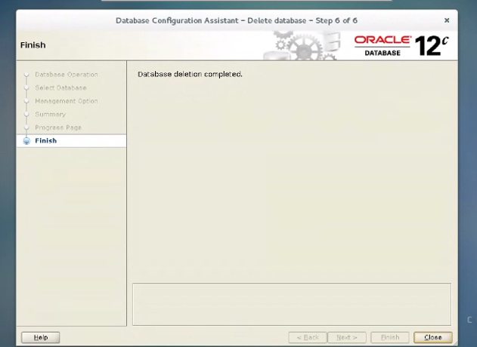

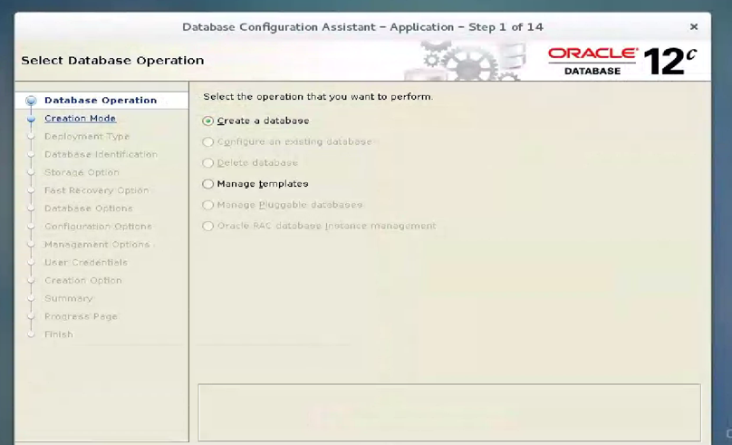

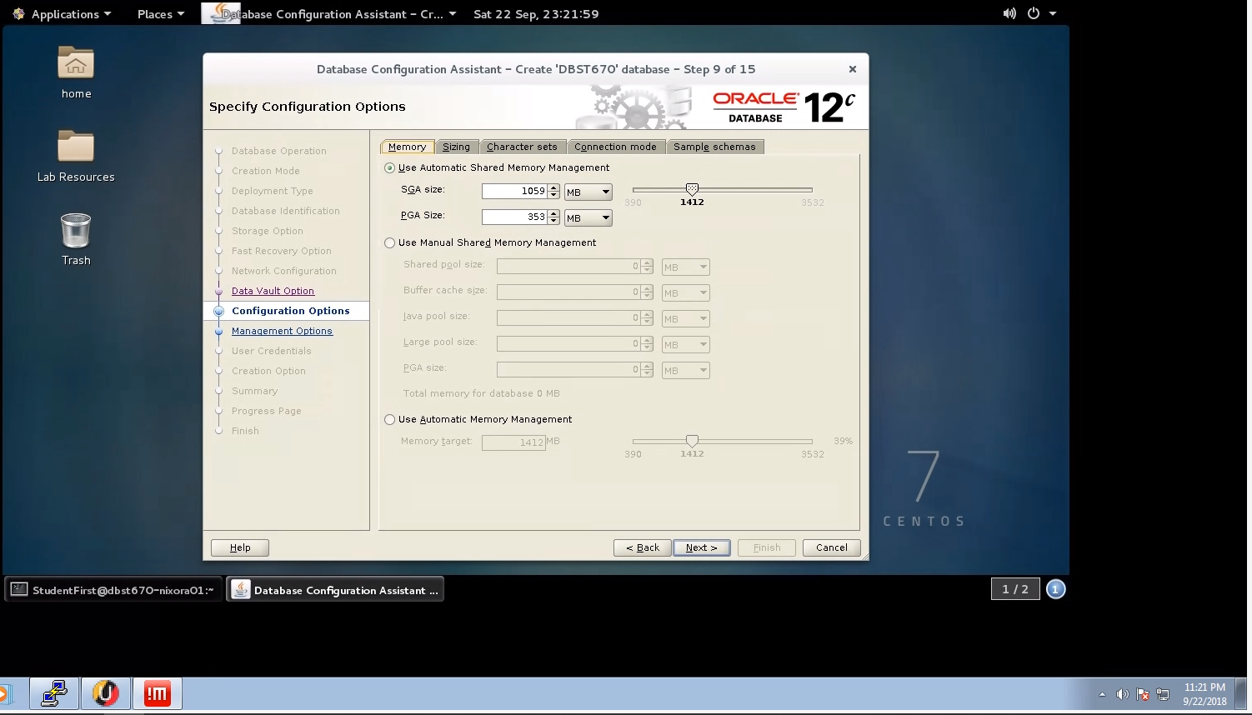

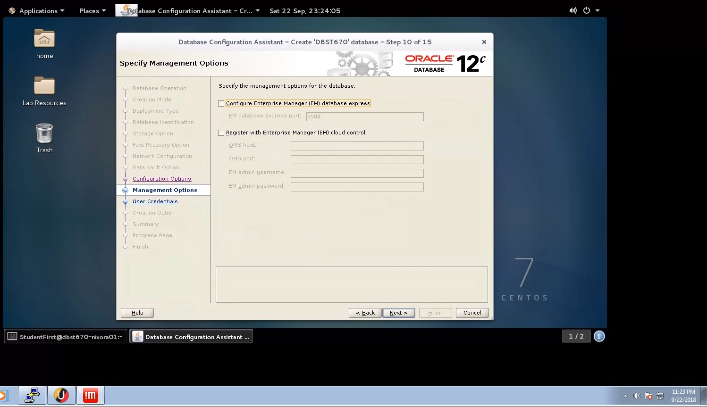

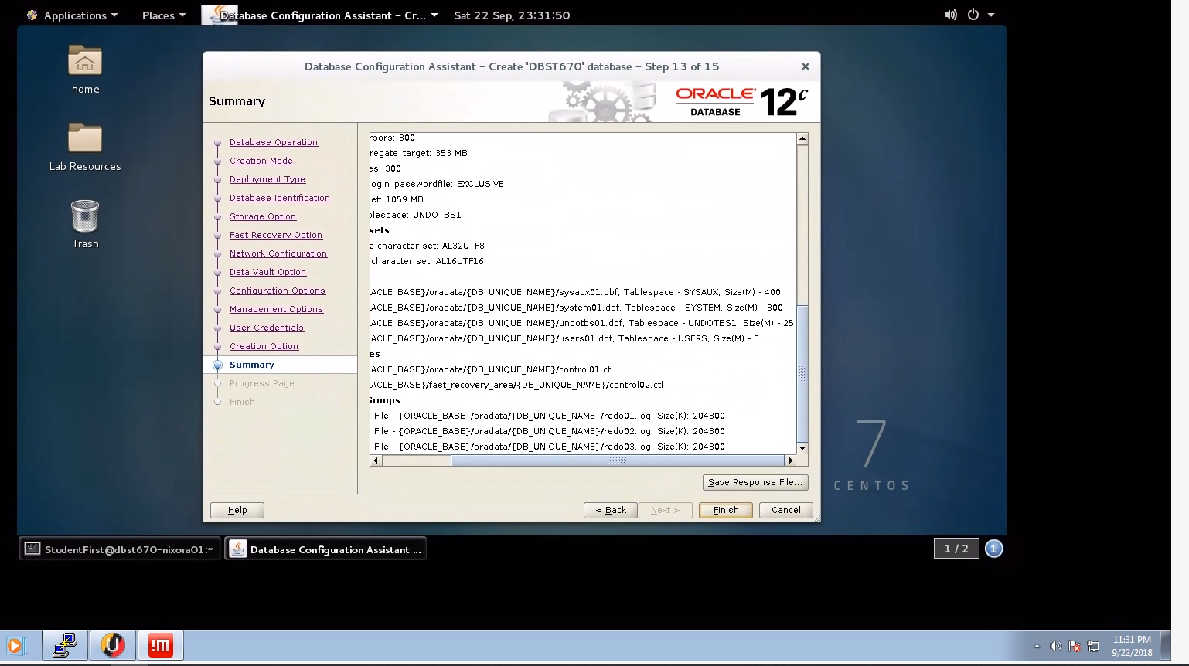

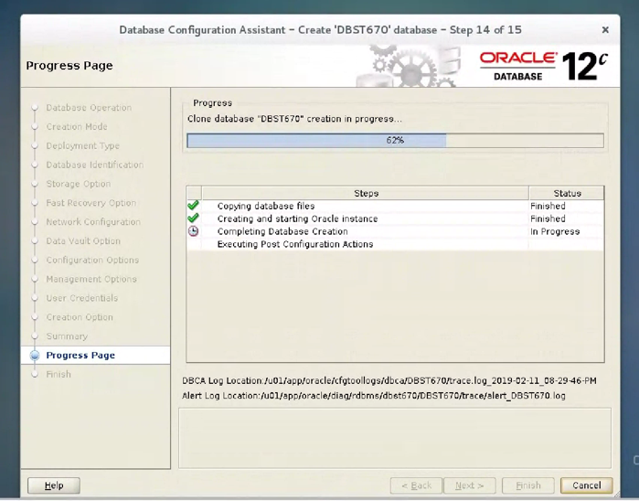

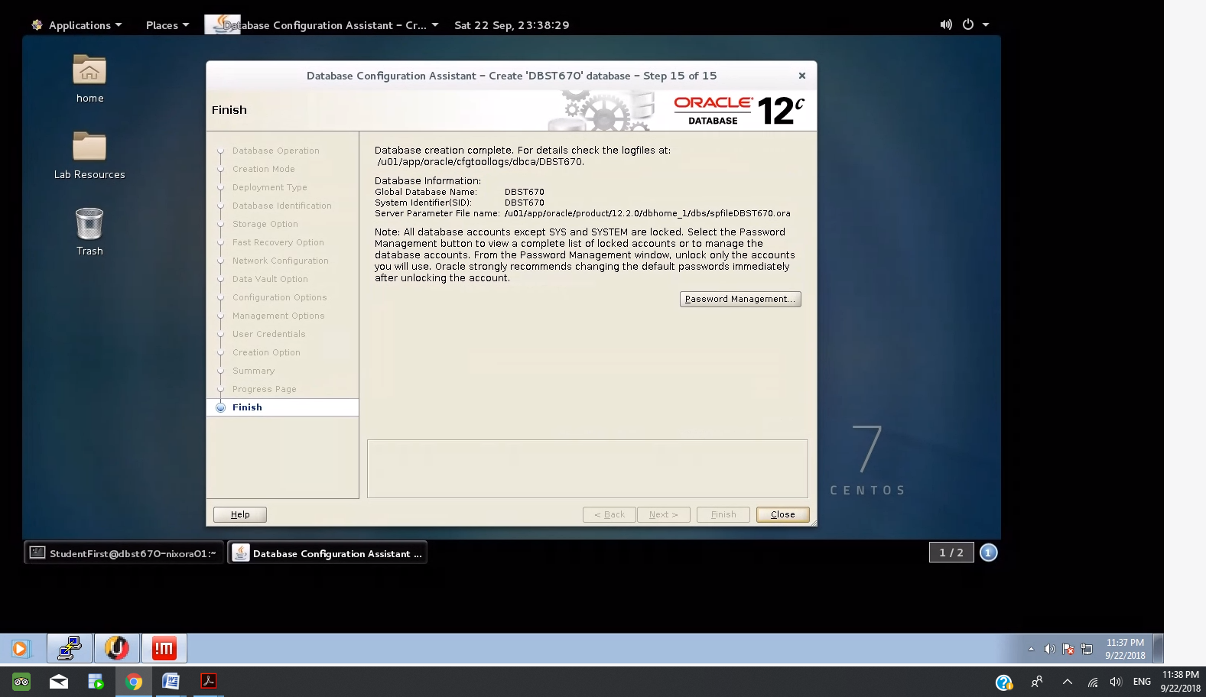

Database instancewas created successfully.

**Installation Checkout Commands and Sample Output**

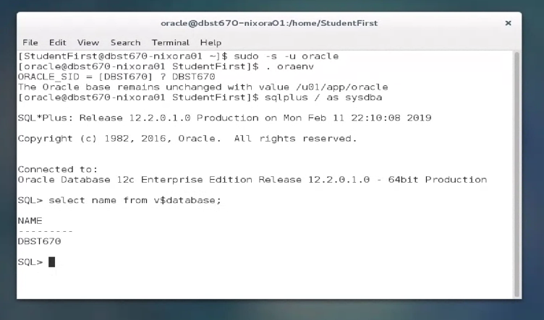

The database instance creation was tested.

Or via PUTTY

The database instance creation was also tested from a Putty session on the AWS.

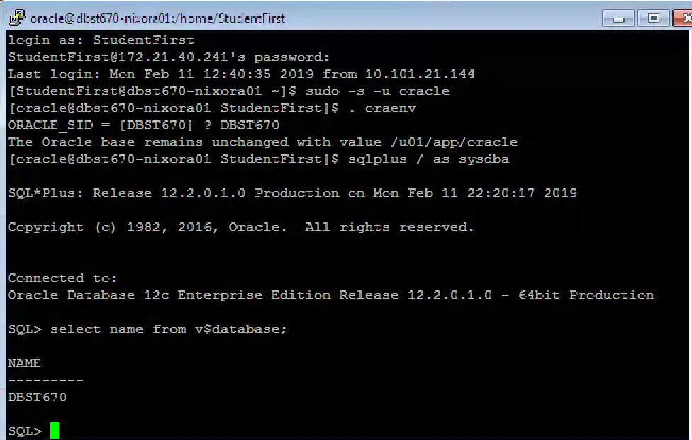

**Initial Backup**

Initial back was performed as follows:

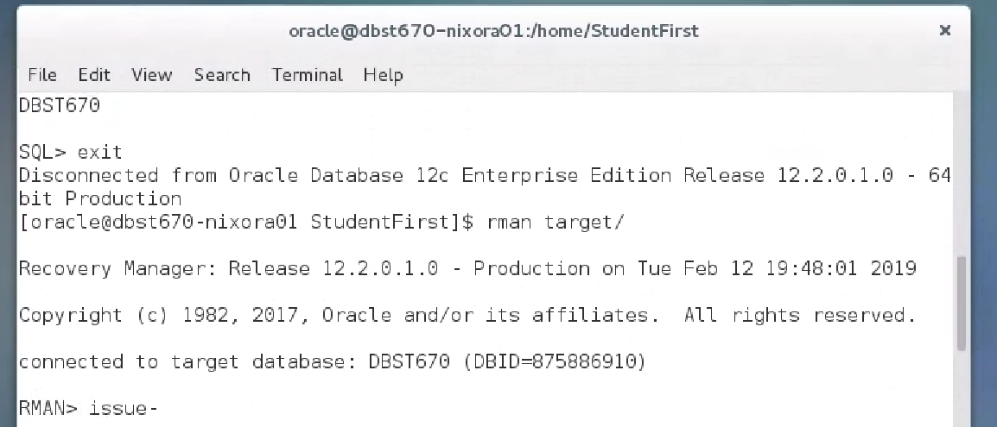

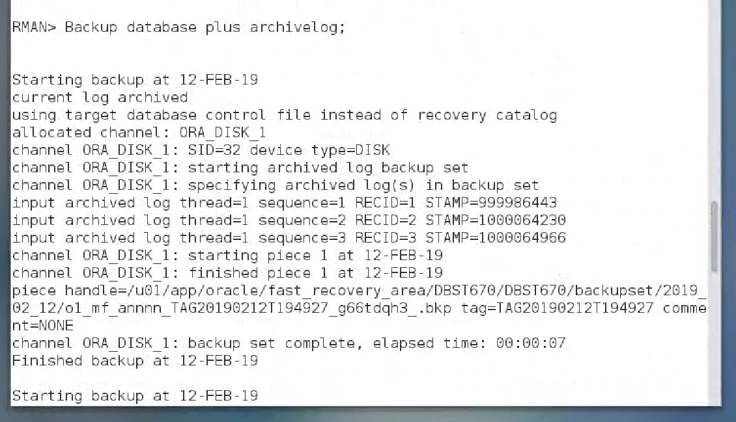

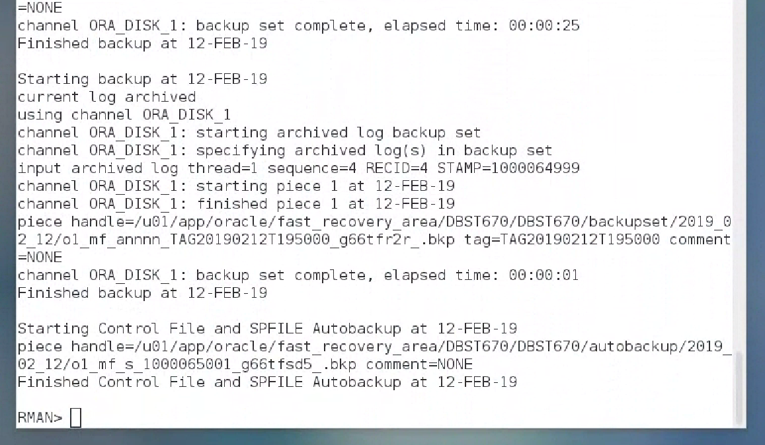

# Create DBA User Script

SQL> SHOW USER;

USER is ""

SQL>

SQL> CONNECT system/sysdba;

Connected.

SQL>

SQL> SHOW USER;

USER is "SYSTEM"

SQL>

SQL> /*Drop Users*/

SQL>

SQL> DROP USER jkamando CASCADE;

User JKAMANDO dropped.

SQL>

SQL> DROP USER tokusanya CASCADE;

User TOKUSANYA dropped.

SQL>

SQL> DROP USER joluwadamilare CASCADE;

User JOLUWADAMILARE dropped.

SQL>

SQL> DROP USER brussell CASCADE;

User BRUSSELL dropped.

SQL>

SQL> DROP USER rseyoum CASCADE;

User RSEYOUM dropped.

SQL>

SQL> DROP USER dbauser CASCADE;

User DBAUSER dropped.

SQL>

SQL> DROP USER datadesignleaduser CASCADE;

User DATADESIGNLEADUSER dropped.

## **Create Users**

SQL>

SQL> /*---------------------------------------------------*/

SQL> /* CREATE USERS */

SQL> /*---------------------------------------------------*/

SQL>

SQL> /*Create DBA User and grant necessary permissions*/

SQL> CREATE USER dbauser IDENTIFIED BY abc123

2 DEFAULT TABLESPACE users

3 TEMPORARY TABLESPACE temp;

User DBAUSER created.

SQL>

SQL> GRANT dba TO dbauser;

Grant succeeded.

SQL>

SQL> /*Disconnect from System and connect to DBAUser*/

SQL> SELECT 'alter system kill session '''

2 || sid

3 || ','

4 || serial#

5 || ''';'

6 FROM v$session

7 WHERE username = 'SYSTEM';

'ALTERSYSTEMKILLSESSION'''||SID||','||SERIAL#||''';'

--------------------------------------------------------------------------------------------------------------

alter system kill session '388,50053';

alter system kill session '394,35833';

SQL>

SQL> DISCONNECT;

Disconnected from Oracle Database 12c Enterprise Edition Release 12.2.0.1.0 - 64bit Production

SQL>

SQL> SHOW USER;

USER is ""

SQL>

SQL> CONNECT DBAUser/abc123;

Connected.

SQL>

SQL> SHOW USER;

USER is "DBAUSER"

SQL>

SQL>

SQL> CREATE USER jkamando IDENTIFIED BY abc123

2 DEFAULT TABLESPACE users

3 TEMPORARY TABLESPACE temp;

User JKAMANDO created.

SQL>

SQL> CREATE USER tokusanya IDENTIFIED BY abc123

2 DEFAULT TABLESPACE users

3 TEMPORARY TABLESPACE temp;

User TOKUSANYA created.

SQL>

SQL> CREATE USER joluwadamilare IDENTIFIED BY abc123

2 DEFAULT TABLESPACE users

3 TEMPORARY TABLESPACE temp;

User JOLUWADAMILARE created.

SQL>

SQL> CREATE USER brussell IDENTIFIED BY abc123

2 DEFAULT TABLESPACE users

3 TEMPORARY TABLESPACE temp;

User BRUSSELL created.

SQL>

SQL> CREATE USER rseyoum IDENTIFIED BY abc123

2 DEFAULT TABLESPACE users

3 TEMPORARY TABLESPACE temp;

User RSEYOUM created.

SQL>

SQL>

SQL> CREATE USER datadesignleaduser IDENTIFIED BY abc123

2 DEFAULT TABLESPACE users

3 TEMPORARY TABLESPACE temp;

User DATADESIGNLEADUSER created.

SQL>

SQL> /*Grant necessary permissions*/

SQL>

SQL> GRANT connect,resource TO jkamando;

Grant succeeded.

SQL>

SQL> GRANT connect,resource TO tokusanya;

Grant succeeded.

SQL>

SQL> GRANT connect,resource TO joluwadamilare;

Grant succeeded.

SQL>

SQL> GRANT connect,resource TO brussell;

Grant succeeded.

SQL>

SQL> GRANT connect,resource TO rseyoum;

Grant succeeded.

SQL>

SQL> GRANT connect,resource TO datadesignleaduser;

Grant succeeded.

SQL>

SQL> GRANT UNLIMITED TABLESPACE TO datadesignleaduser;

Grant succeeded.

# Alter Users Script

## **Create Tablespaces and Alter Users**

SQL>

SQL> /*---------------------------------------------------*/

SQL> /* CREATE TABLESPACE AND ASSIGN TO USERS */

SQL> /*---------------------------------------------------*/

SQL>

SQL> CREATE TABLESPACE "USER_DATA1" LOGGING DATAFILE '/u01/app/oracle/oradata/DBST670/user_data101.dbf' SIZE 3004K REUSE AUTOEXTEND ON NEXT 512K MAXSIZE 65536K EXTENT MANAGEMENT LOCAL;

TABLESPACE "USER_DATA1" created.

SQL> CREATE TABLESPACE "USER_DATA2" LOGGING DATAFILE '/u01/app/oracle/oradata/DBST670/user_data201.dbf' SIZE 2408K REUSE AUTOEXTEND ON NEXT 512K MAXSIZE 65536K EXTENT MANAGEMENT LOCAL;

TABLESPACE "USER_DATA2" created.

SQL> CREATE TABLESPACE "USER_INDX1" LOGGING DATAFILE '/u01/app/oracle/oradata/DBST670/user_indx01.dbf' SIZE 4210K REUSE AUTOEXTEND ON NEXT 512K MAXSIZE 65536K EXTENT MANAGEMENT LOCAL;

TABLESPACE "USER_INDX1" created.

SQL> CREATE TEMPORARY TABLESPACE "USER_TEMP" TEMPFILE '/u01/app/oracle/oradata/DBST670/user_temp01.dbf' SIZE 16384K REUSE AUTOEXTEND ON NEXT 512K MAXSIZE 65536K EXTENT MANAGEMENT LOCAL;

TABLESPACE "USER_TEMP" created.

SQL>

SQL> /*Alter unprivileged user tablespace*/

SQL> ALTER USER JKamando DEFAULT TABLESPACE user_data1 TEMPORARY TABLESPACE user_temp;

User JKAMANDO altered.

SQL> ALTER USER TOkusanya DEFAULT TABLESPACE user_data1 TEMPORARY TABLESPACE user_temp;

User TOKUSANYA altered.

SQL> ALTER USER JOluwadamilare DEFAULT TABLESPACE user_data1 TEMPORARY TABLESPACE user_temp;

User JOLUWADAMILARE altered.

SQL> ALTER USER BRussell DEFAULT TABLESPACE user_data1 TEMPORARY TABLESPACE user_temp;

User BRUSSELL altered.

SQL> ALTER USER RSeyoum DEFAULT TABLESPACE user_data1 TEMPORARY TABLESPACE user_temp;

User RSEYOUM altered.

SQL> ALTER USER DBAUser DEFAULT TABLESPACE user_data1 TEMPORARY TABLESPACE user_temp;

User DBAUSER altered.

SQL> ALTER USER DataDesignLeadUser DEFAULT TABLESPACE user_data1 TEMPORARY TABLESPACE user_temp;

User DATADESIGNLEADUSER altered.

SQL>

SQL> /*Disconnect from DBAUser, Login as DataDesignLeadUser*/

SQL> SELECT 'alter system kill session '''

2 || sid

3 || ','

4 || serial#

5 || ''';'

6 FROM v$session

7 WHERE username = 'DBAUSER';

'ALTERSYSTEMKILLSESSION'''||SID||','||SERIAL#||''';'

--------------------------------------------------------------------------------------------------------------

alter system kill session '268,10717';

SQL>

SQL> DISCONNECT;

Disconnected from Oracle Database 12c Enterprise Edition Release 12.2.0.1.0 - 64bit Production

SQL>

SQL> SHOW USER;

USER is ""

SQL>

SQL> CONNECT DataDesignLeadUser/abc123;

Connected.

SQL>

SQL> SHOW USER;

USER is "DATADESIGNLEADUSER"

**Export and Import**

## **Traditional Export / Import Example**

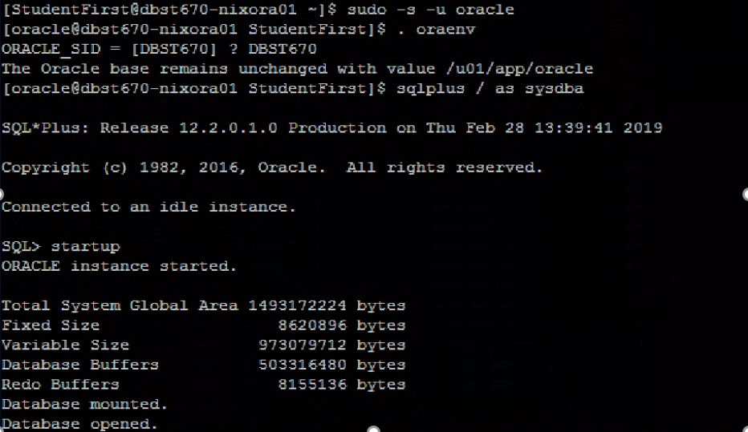

Test user is created.

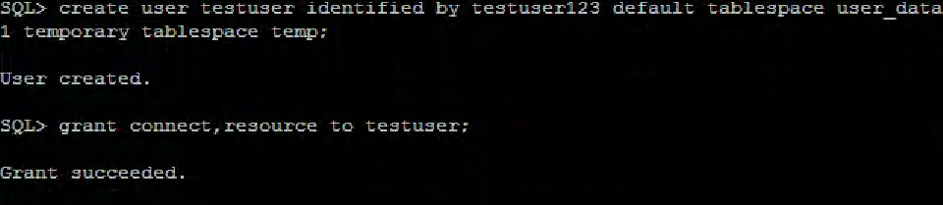

The table with primary key is created.

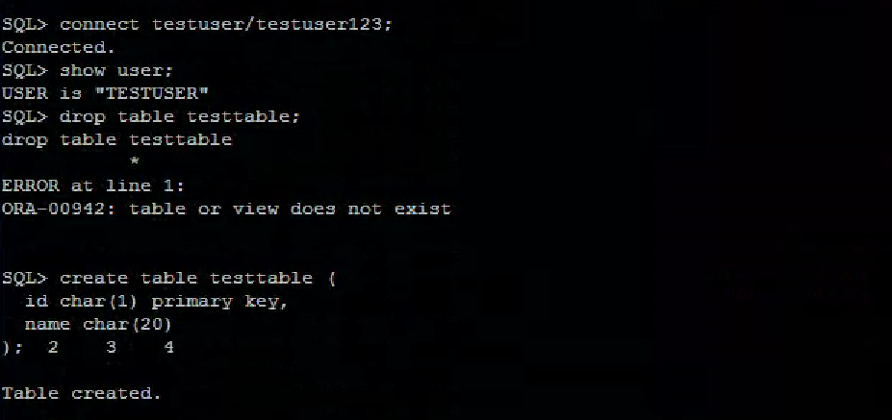

Once the test table is created then populated with data.

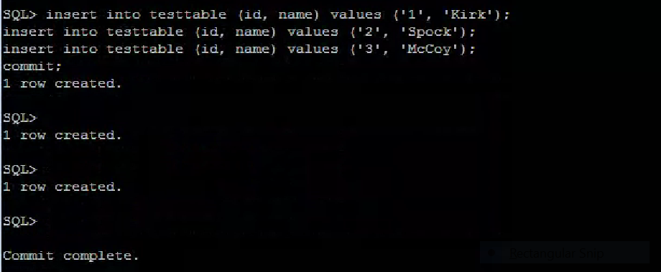

Verify the test table is created.

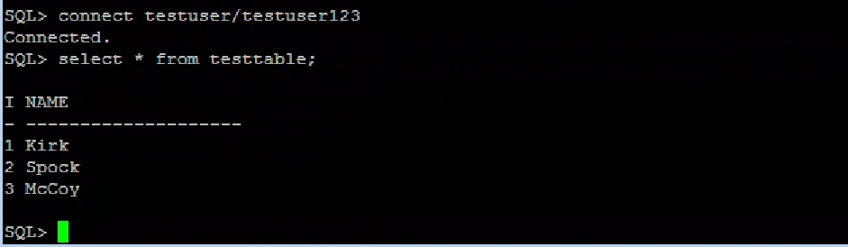

Exp Command: exp help=y (This command displays the available parameters).

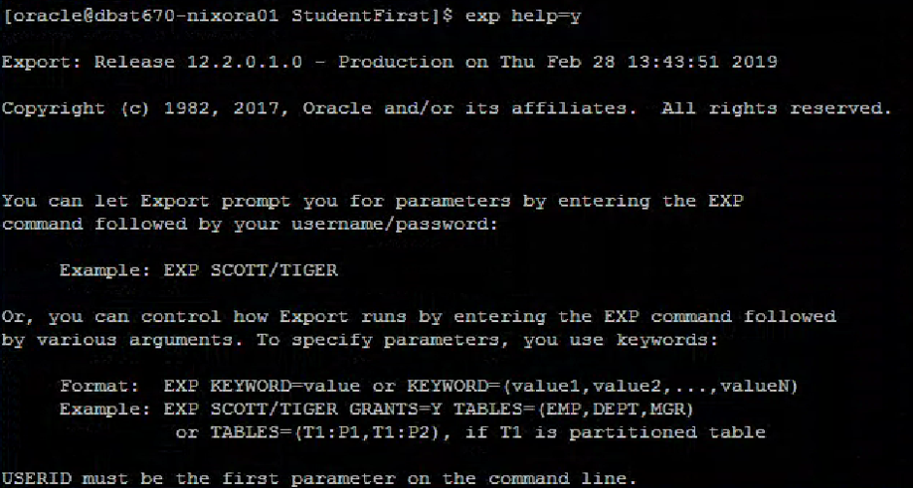

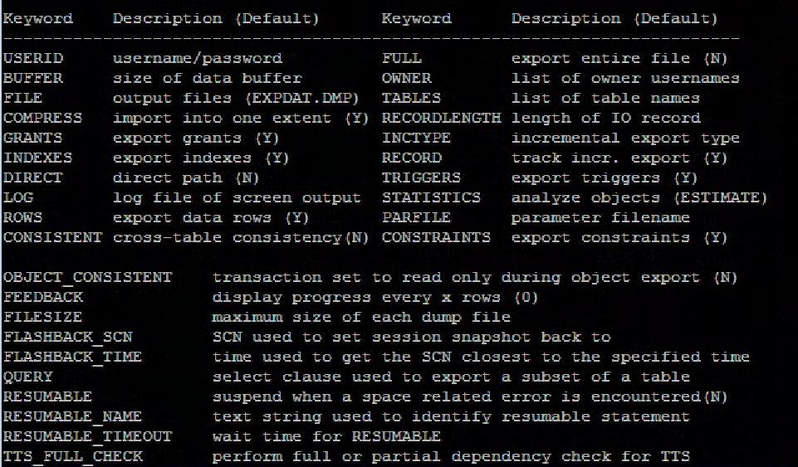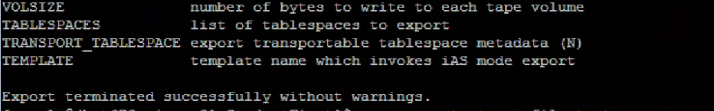

exp owner=testuser file=testuser.exp

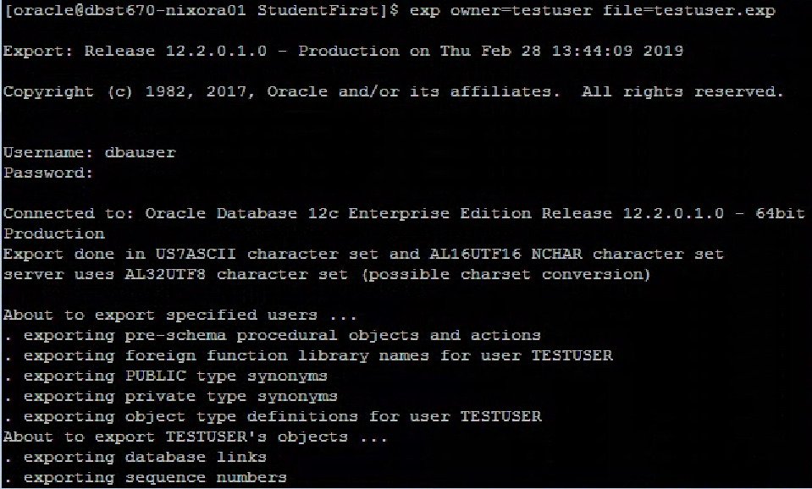

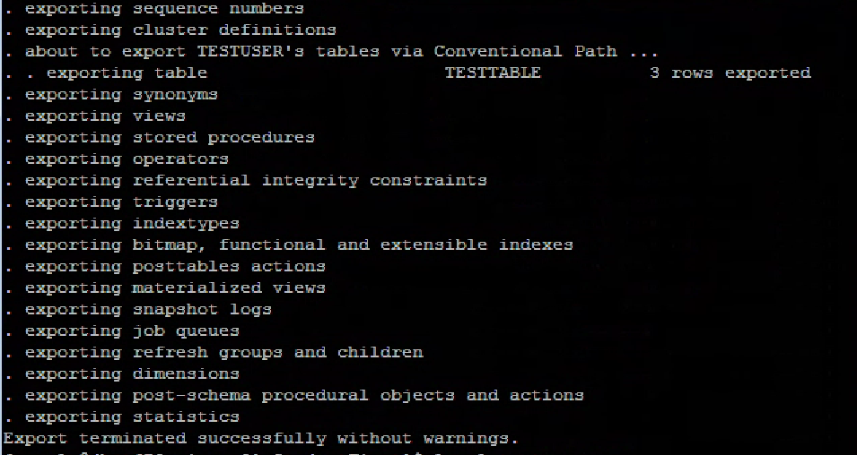

ls -l testuser.exp



Drop the table with primary key (test table).

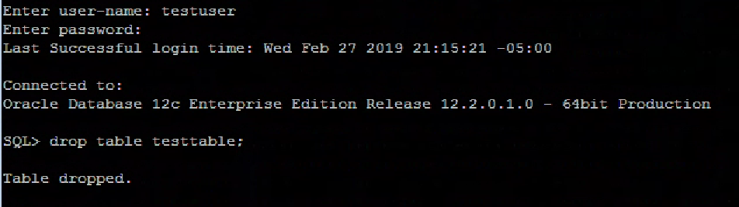

Imported the test table

imp file=testuser.exp fromuser=testuser touser=testuser

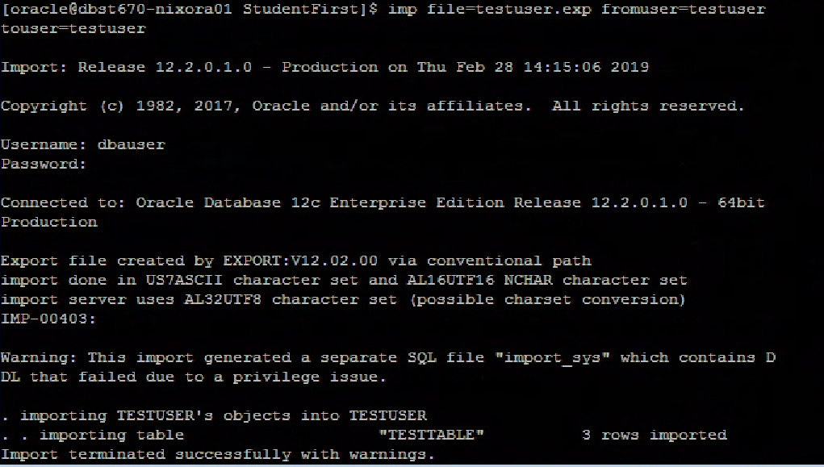

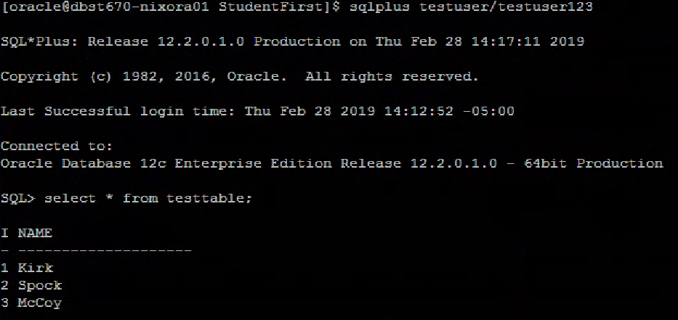

The above output shows the dropped table is back into the database.

**Scenarios and Explanation**

* Scenario 1 (this is the scenario described above)

The table with primary key is created and populated with data.



Verify the test table is created.

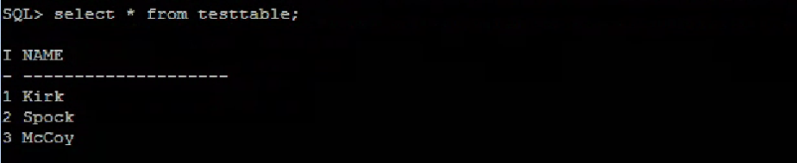

At the UNIX prompt, exported the test table and list the exported file.

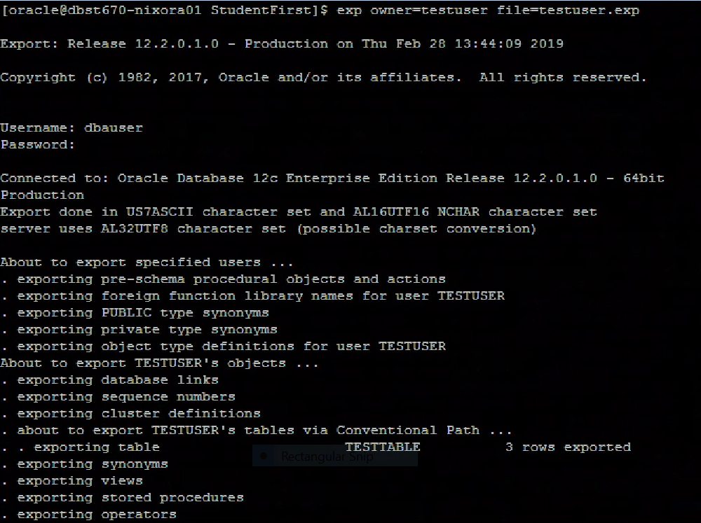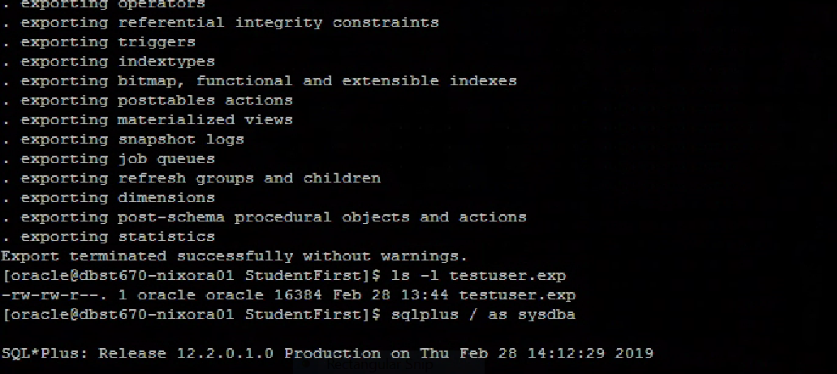

Logged in as test user and dropped the table with primary key (test table)



At the UNIX prompt, the test table is imported.



Verified the test table is back.



In scenario 1, the table with primary key (test table) was exported and dropped. Then the table was imported successfully. At this point, the test table is recreated and back into the database.

* Scenario 2

Verify the table with a primary key (test table) is created.



At the UNIX prompt, exported the table and list the exported file.

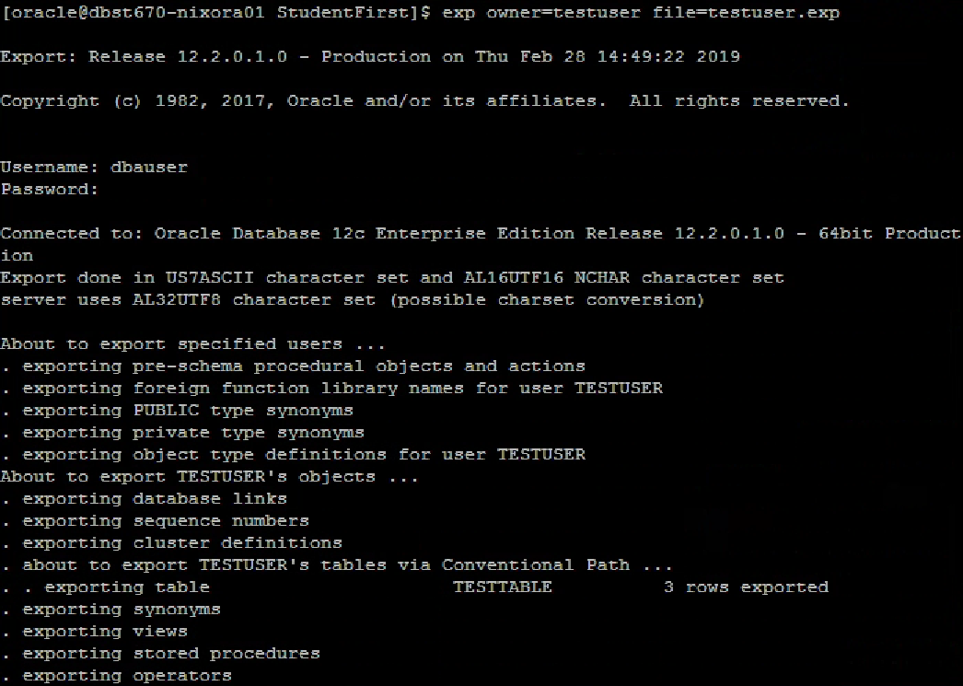

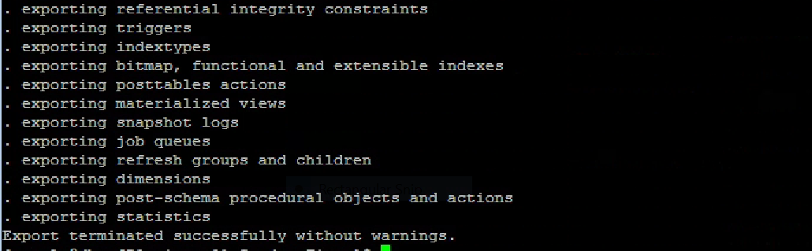

Logged in as test user and deleted one row from the test table.

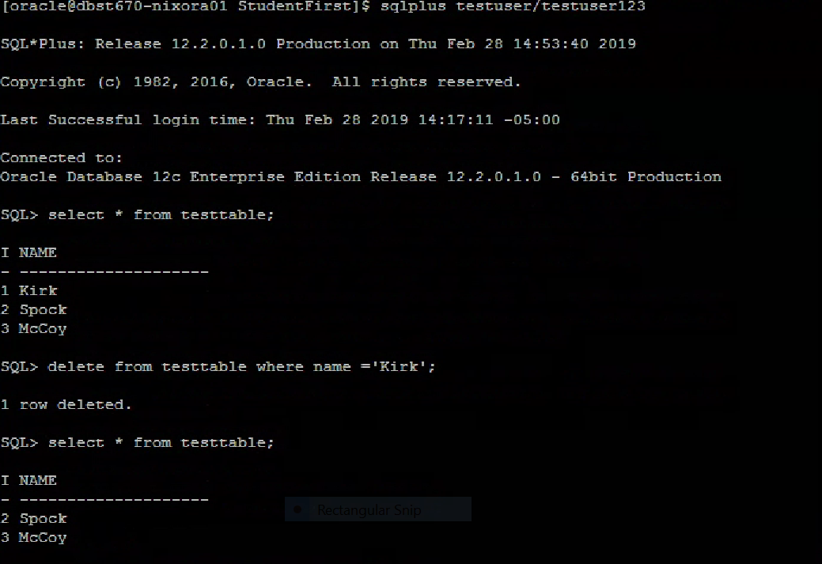

At the UNIX prompt, data import is performed.

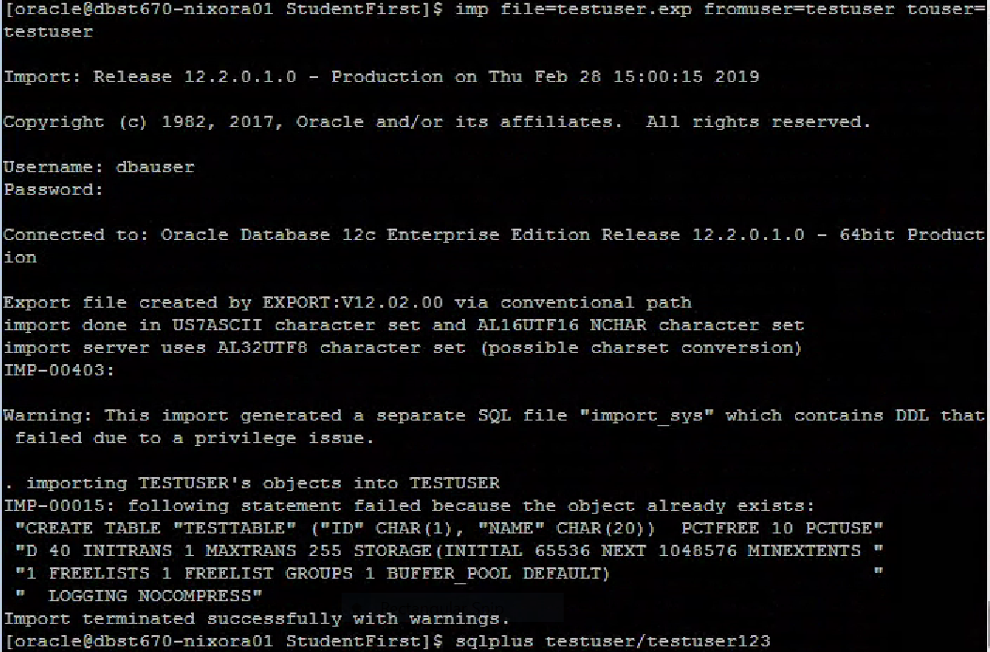

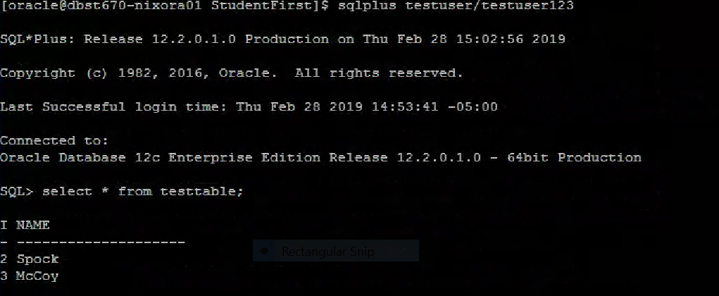

In scenario 2, the table with primary key (test table) was exported and only one row was deleted. At this point, the import failed and didn’t bring back the entire contents of the test table since the test table already exists and unable to recreate the entire table over the existing table. Therefore, the import can only recover everything or not at all.

* Scenario 3

The table without primary key (test table 1) is created and populated with data.

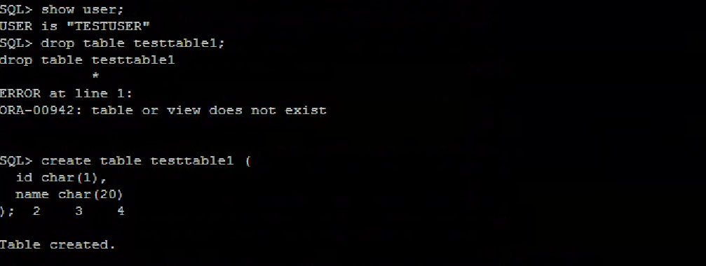

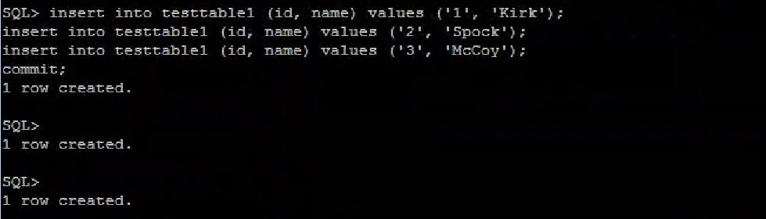

Verify the test table 1 is created.

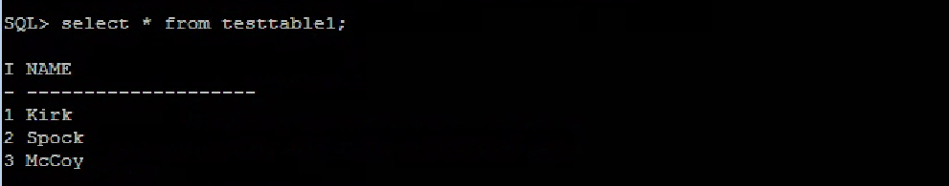

At the UNIX prompt, exported test table 1 and list the exported file.

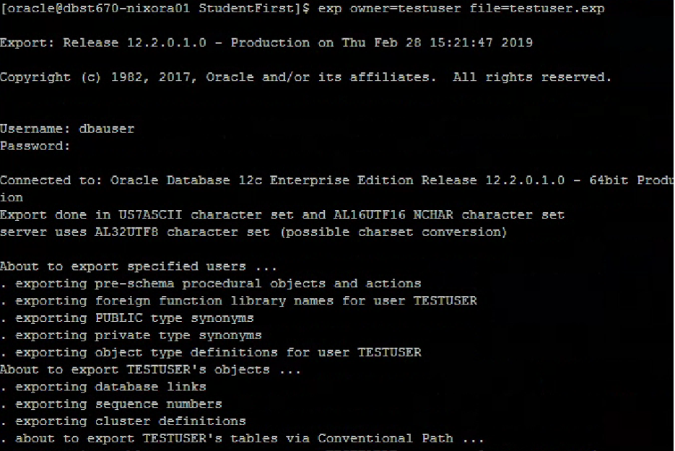

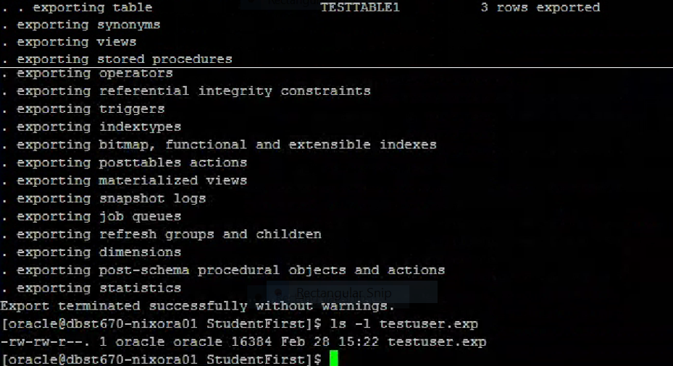

Logged in as test user and deleted one row from the test table 1.

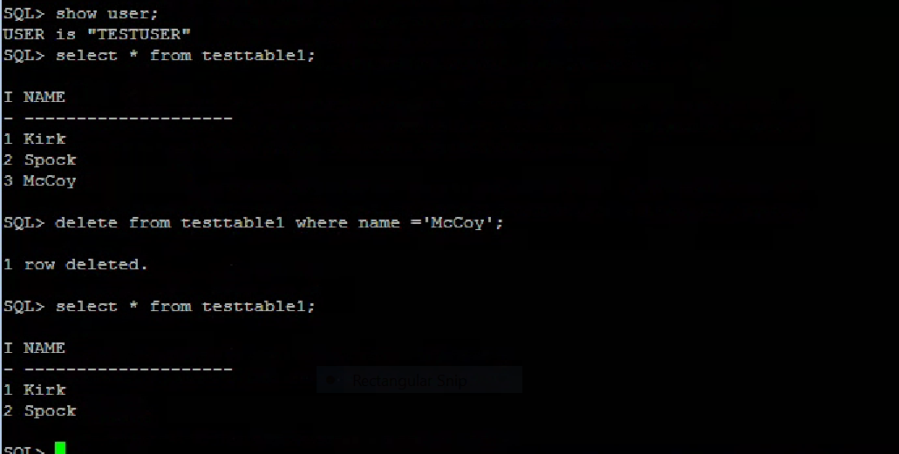

At the UNIX prompt, data import is performed.

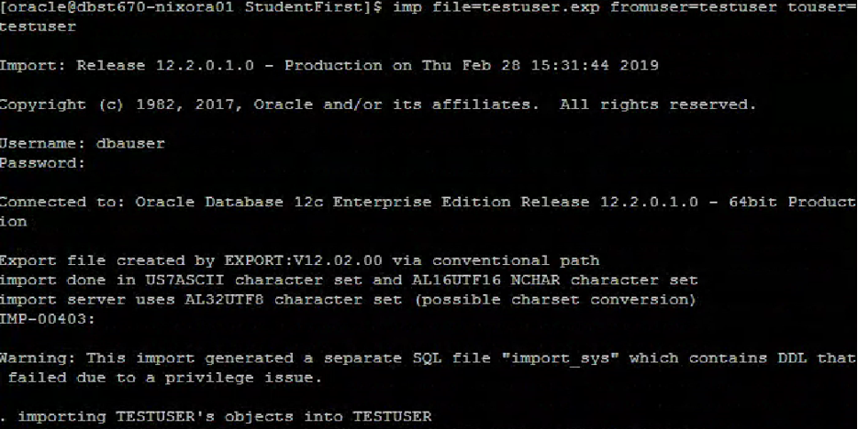

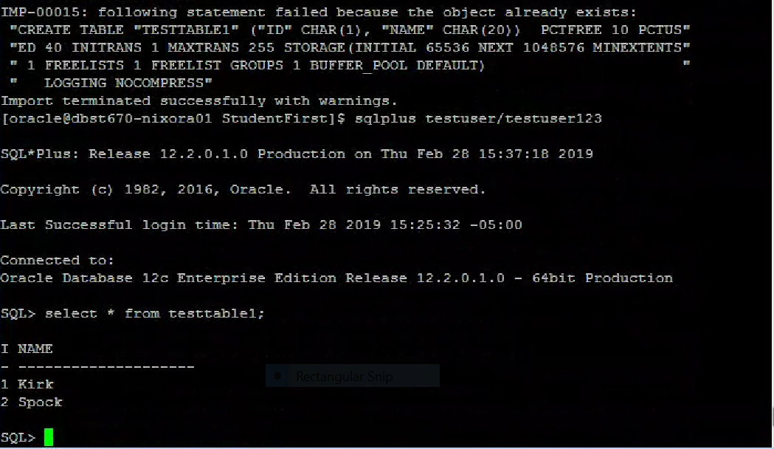

In scenario 3, the result was similar to scenario 2. Meaning, the import failed and didn’t bring back the entire contents of the test table 1 since the test table1 already exists and unable to recreate the entire table over the existing table. Therefore, the import can only recover everything or not at all.

* Scenario 4

The table with primary key is created and populated with data.

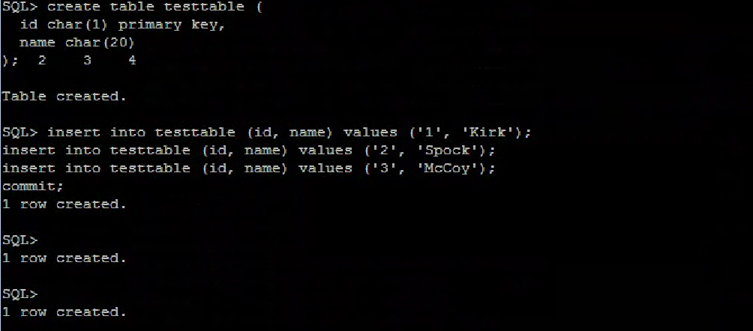

Verify the table is created.

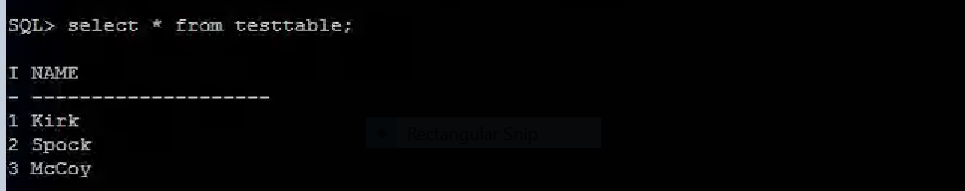

At the UNIX prompt, exported test table and list the exported file.

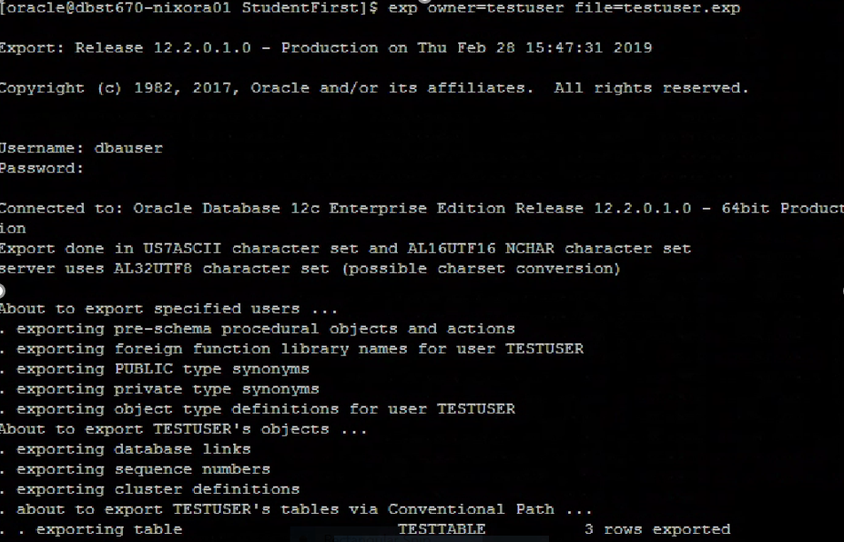

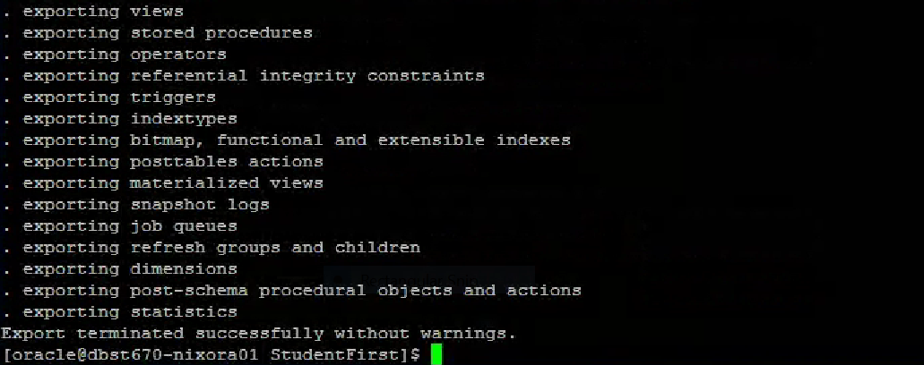

Logged in as DBA user and dropped the test table.

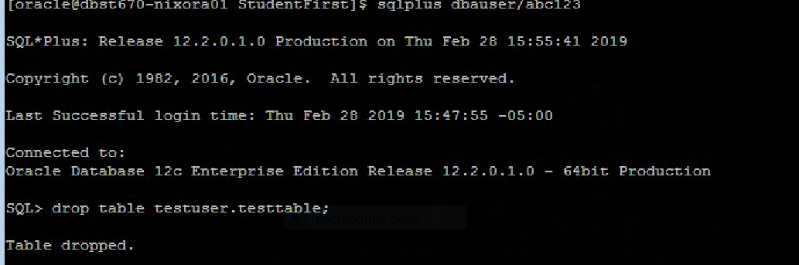

At the UNIX prompt, import the table using imp command.

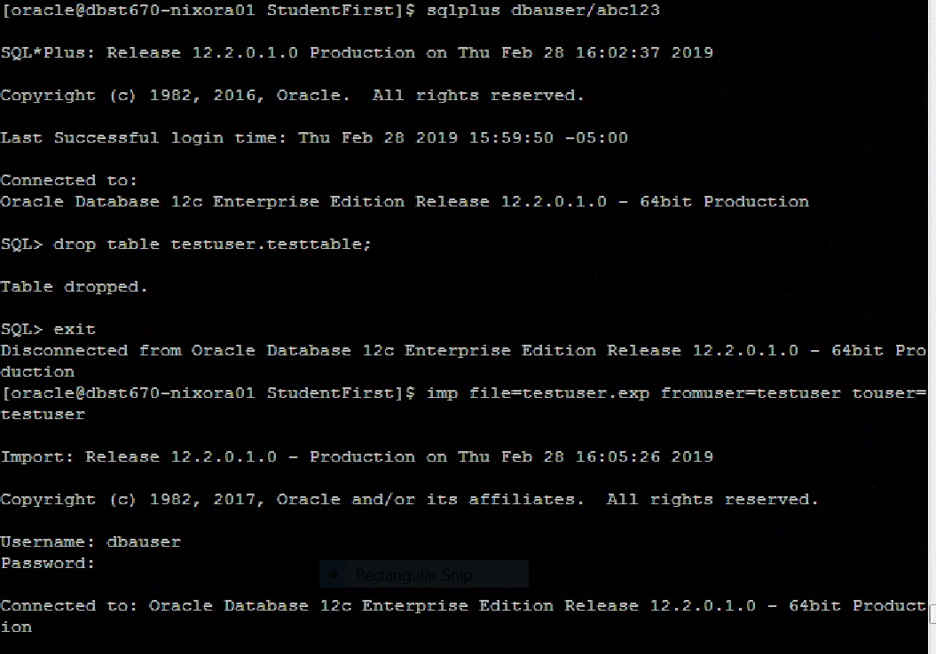

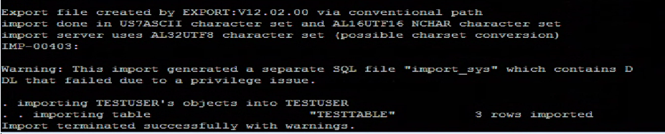

Verified the test table is back.

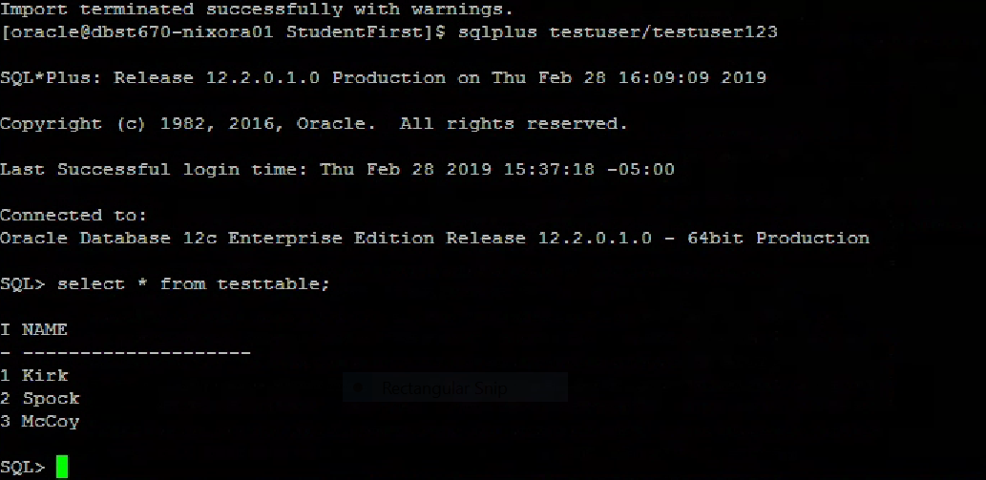

In scenario 4, the test table with full content was back into the database. That means, the oracle only checks if the test table does exist or not under the particular schema. It doesn’t matter who dropped the table.

* Scenario 5 (Test scenario)

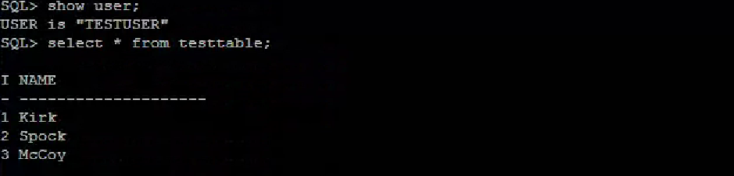

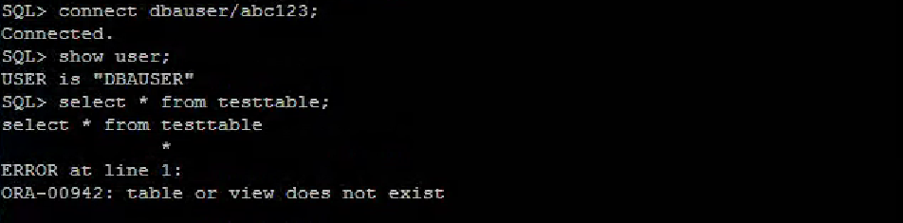

At the UNIX prompt, imported the test table from test user schema to dbauser schema.

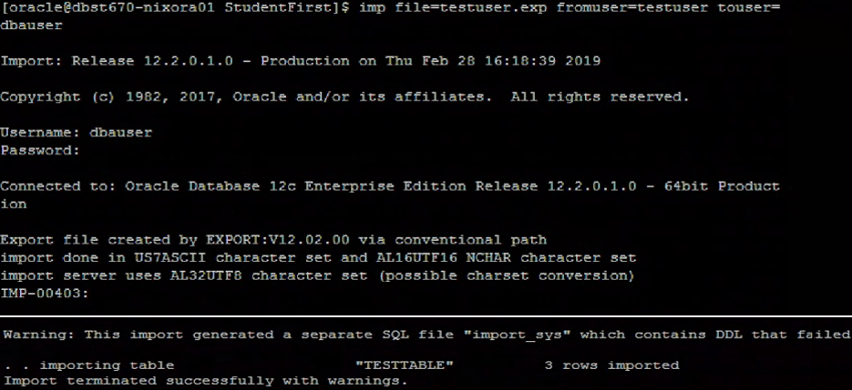

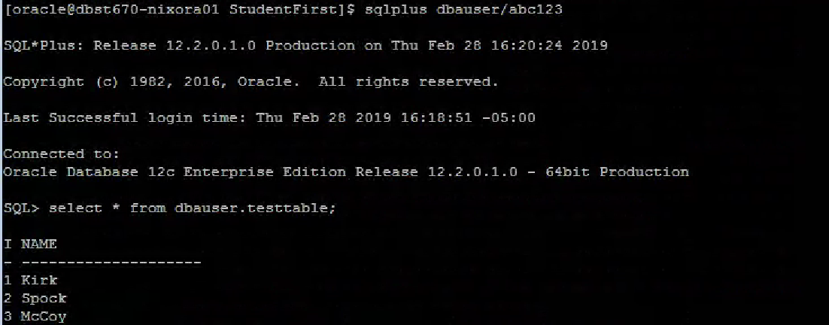

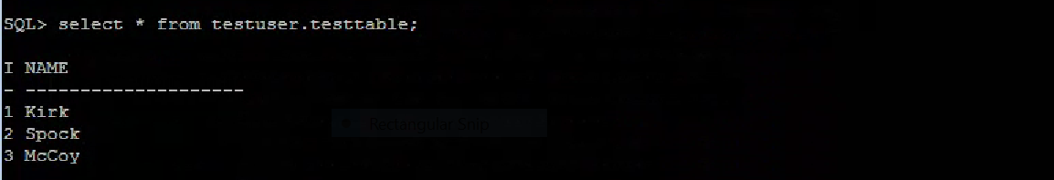

In scenario 5, the import command imp file=testuser.exp fromuser=testuser touser=dbauser used to export the test table with primary key (test table) from the testuser schema to the dbauser schema. The above result shows the import process successfully completed and created the test table since the test table didn’t present in the dbauser schema. Therefore, we have two similar tables in two different schemas (testuser and dbauser).

**Using the Data Pump Exdp/Imdp**

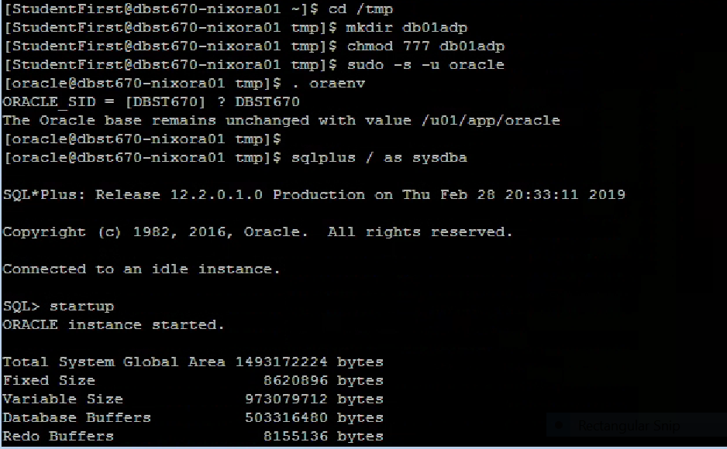

Directory was created.

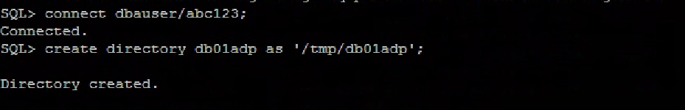

**Scenarios and Explanation**

* Scenario 1

Logged in as test table owner and created the table with a primary key





At the UNIX prompt, expdp the table with primary key (test table).

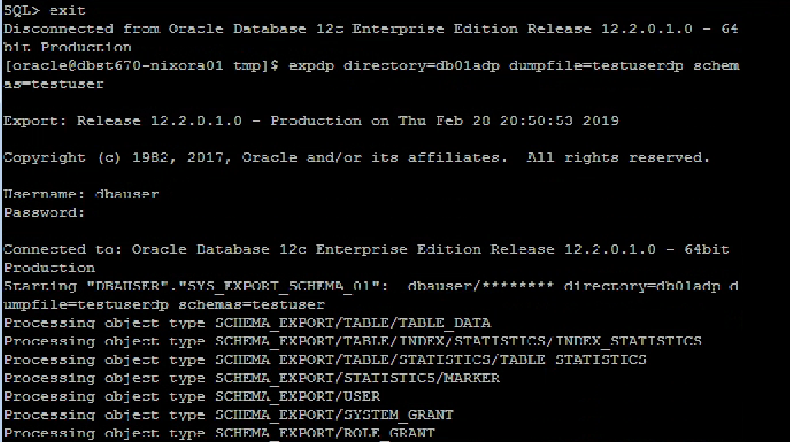

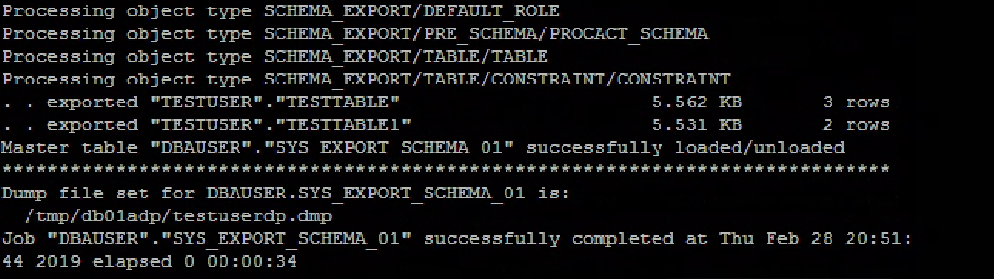

Logged in as test user and dropped the test table.

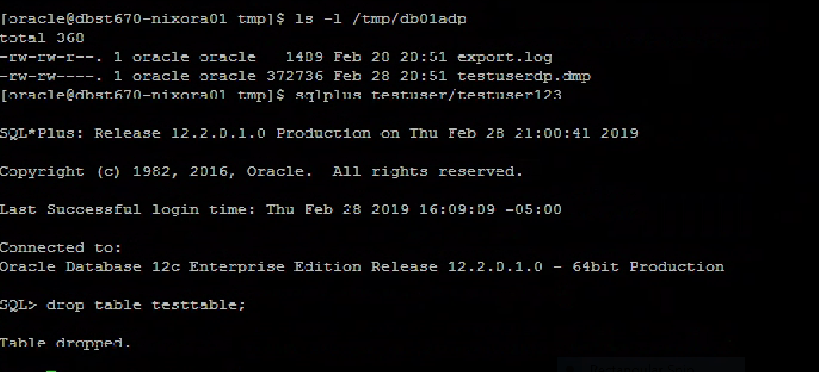

At the UNIX prompt, impdp is performed.

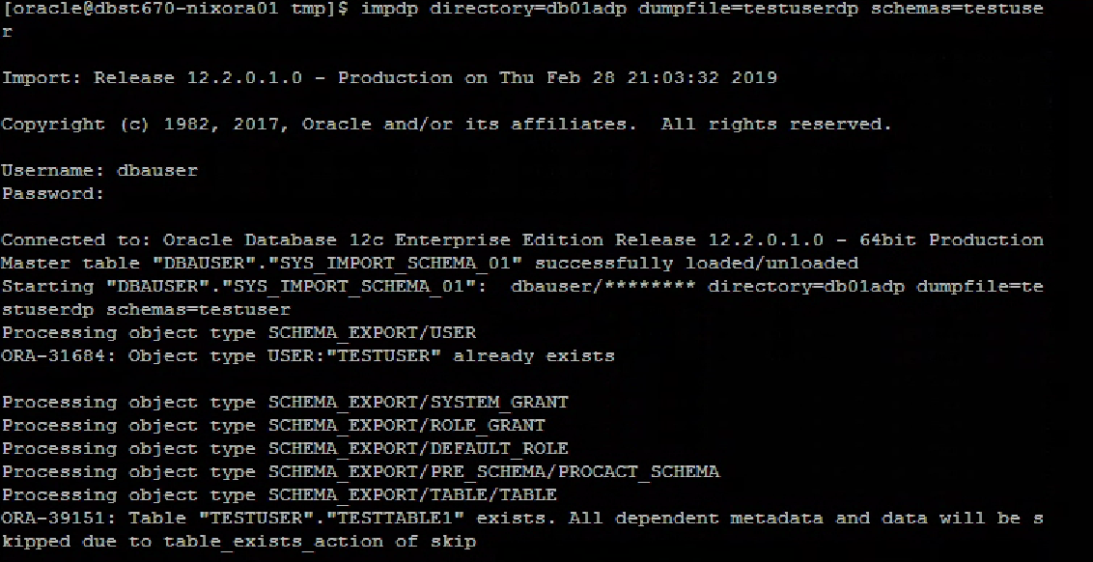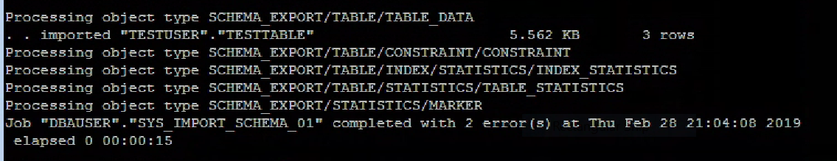

Logged in as test user and verify impdp brought back the test table.

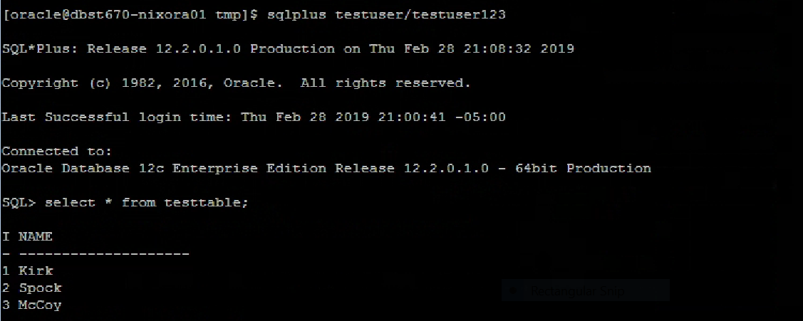

In scenario 1, expdb the table with primary key (test table) and dropped the test table. Then impdp was completed. At this point, impdp brought back the test table into the database.

* Scenario 2

Logged in as the test table owner and created the table with a primary key

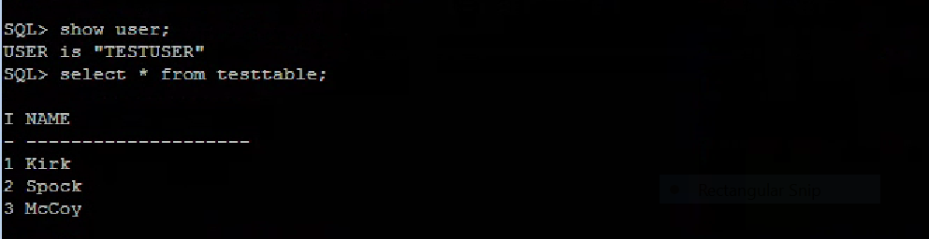

At the UNIX prompt, expdp the table with primary key (test table).

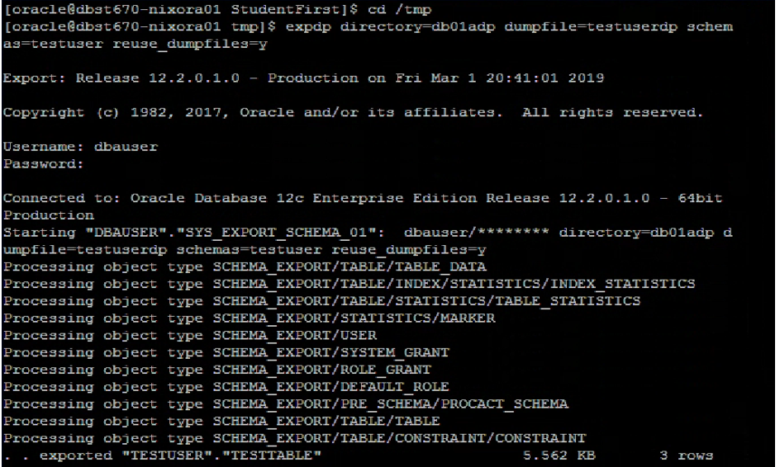

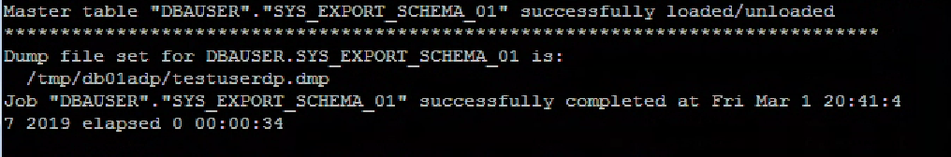

Logged in as test user and deleted one row from the test table.

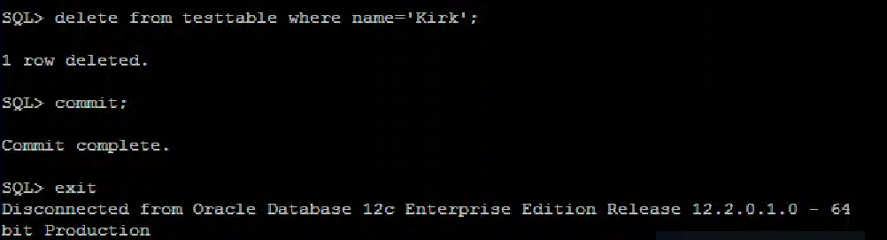

At the UNIX prompt, run the impdp command.

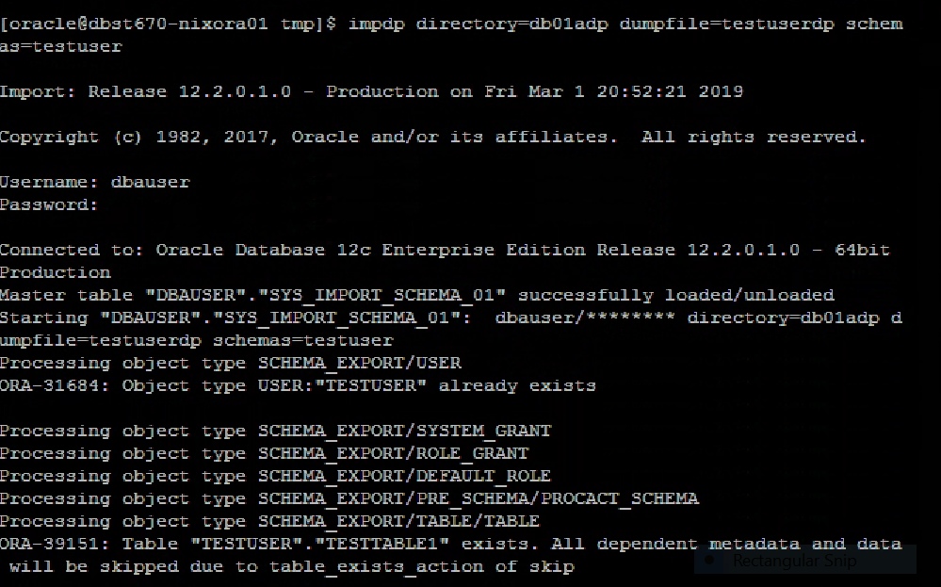

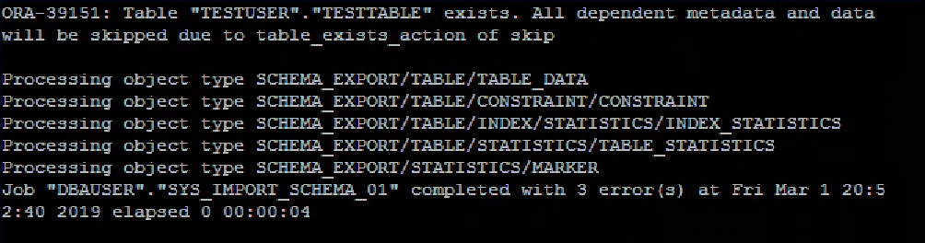

Logged in as the test user and verify impdp command brought back the data.

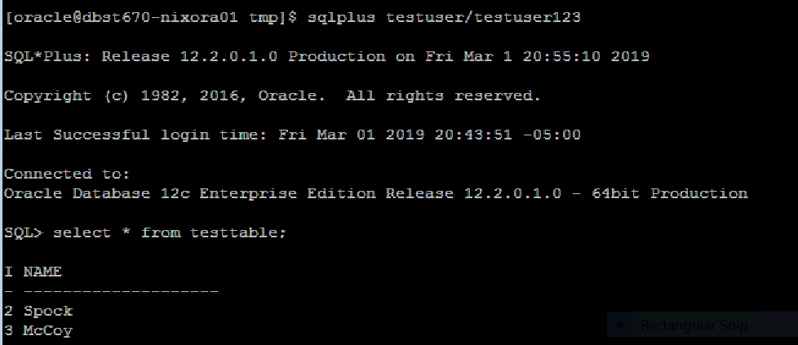

In scenario 2, the table with primary key (test table) was exported and only one row was deleted. Here, the import process skipped over inserting the data and failed. That means, it didn’t bring back the entire contents of the test table since the test table already exists and the impdp command threw an error. For such kind of scenario, it would have been useful to apply the parameter TABLE_EXISTS_ACTION. This parameter helps to insert the missing row and replace the table which already exists.

* Scenario 3

The table without primary key (test table 1) is created and populated with data.

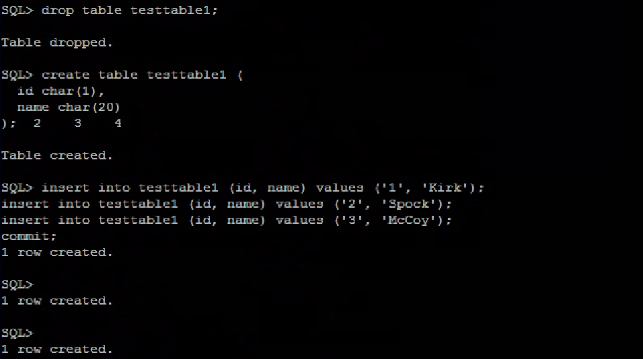

Verify the test table 1 was created.

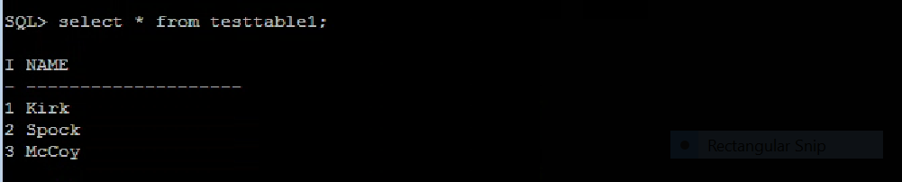

At the UNIX prompt, exported test table 1.

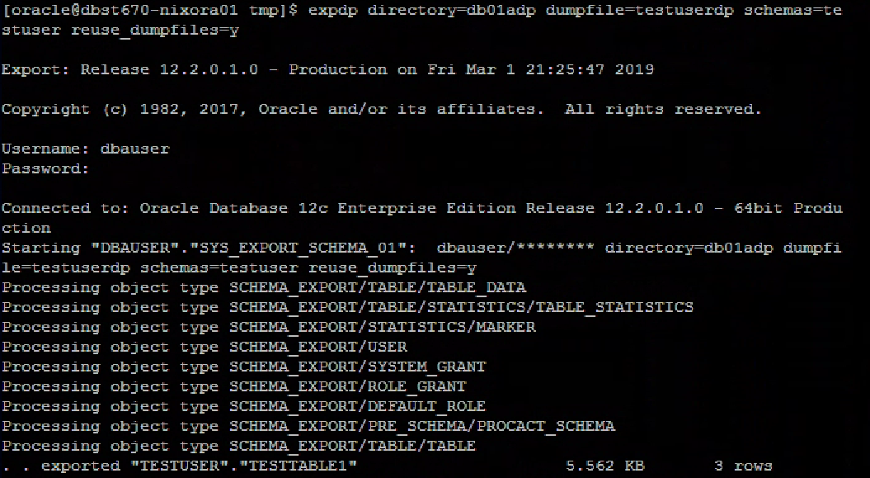

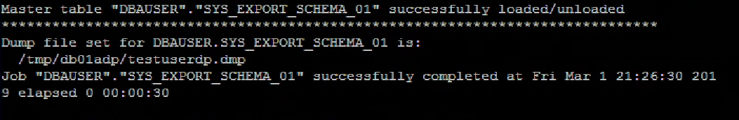

Logged in as test user and deleted one row from the test table 1.

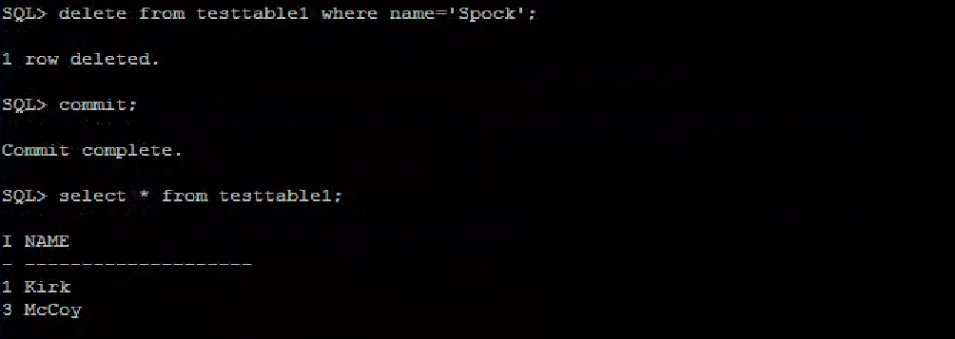

At the UNIX prompt, run the impdp command.

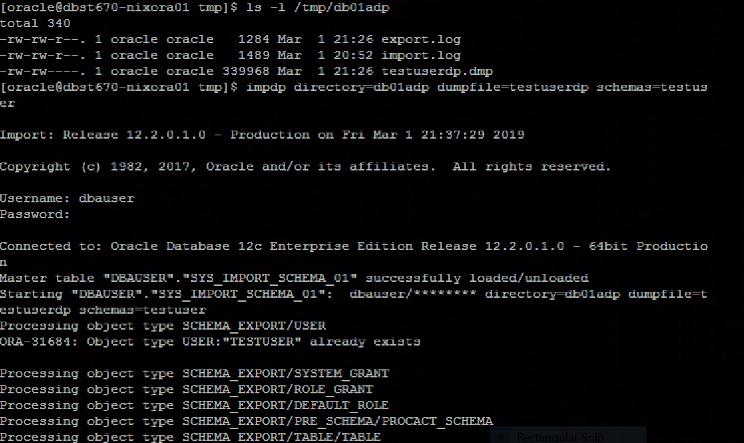

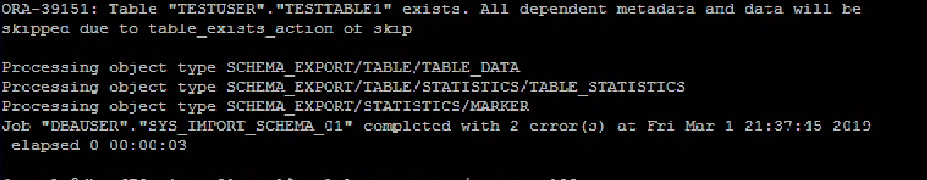

Logged in as test user and verify impdp command brought back the data.

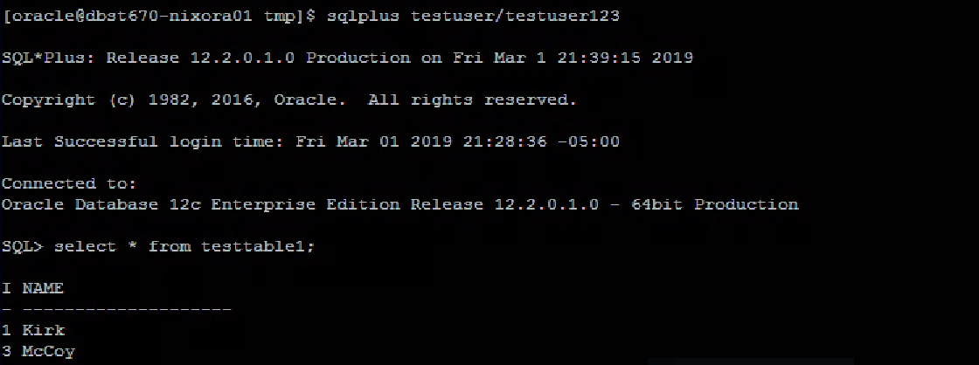

In scenario 3, the result was similar to scenario 2. the table without primary key (test table 1) was exported and only one row deleted. In this case, the import process skipped over inserting the data and failed. It didn’t bring back the entire contents of the test table 1 since the test table already exists and the impdp command threw an error. Likewise, it would have been useful to apply the parameter TABLE_EXISTS_ACTION. This parameter helps to insert the missing row and replace the table which already exists.

* Scenario 4

The table with primary key (test table) is created and populated with data.

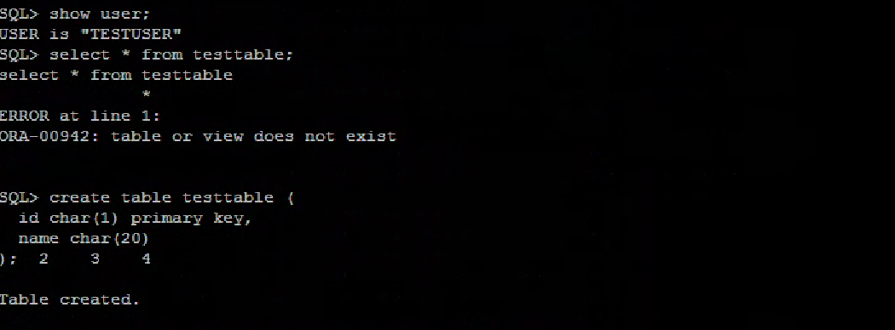

Verify the table was created.

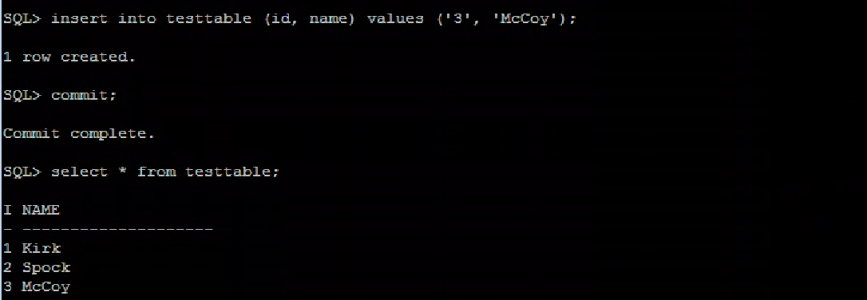

At the UNIX prompt, run expdp command.

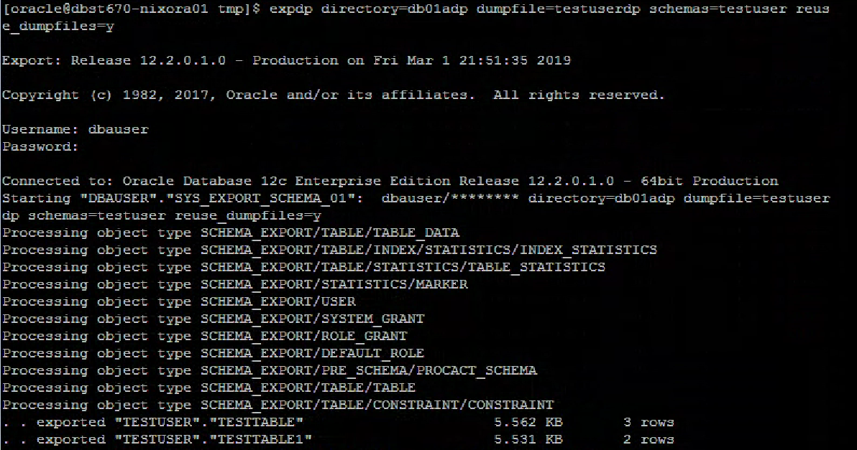

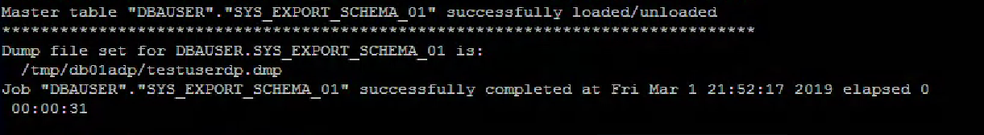

Logged in as DBA user and dropped the test table.

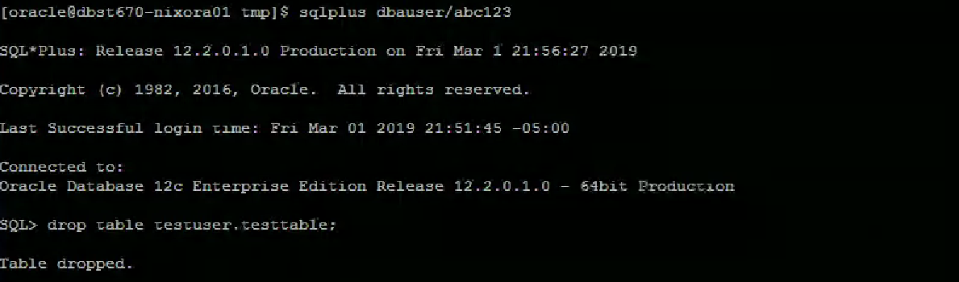

At the UNIX prompt, import the table using impdp command.

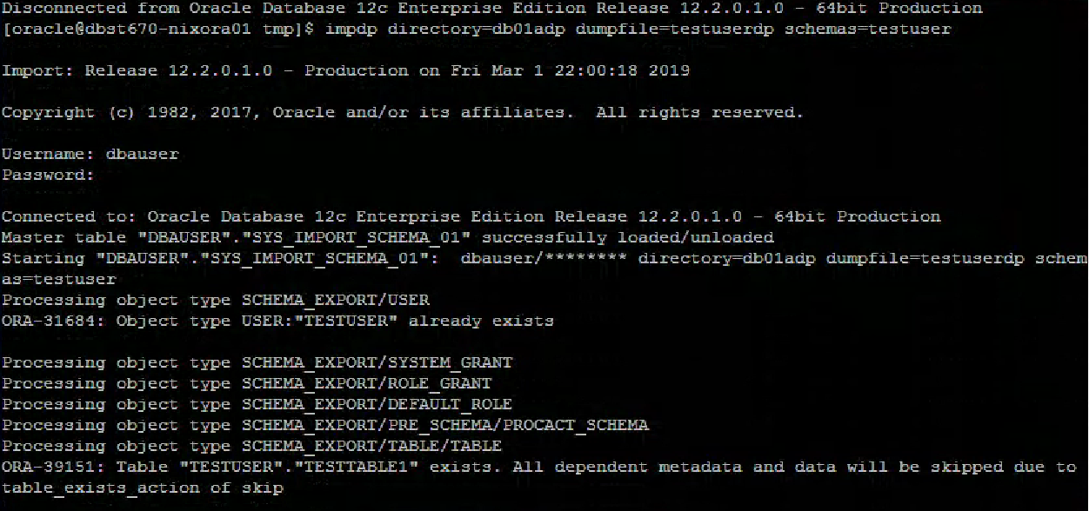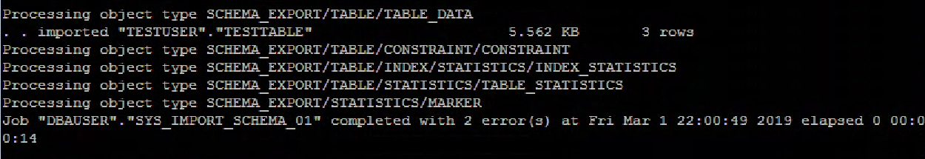

Verify the table was created.

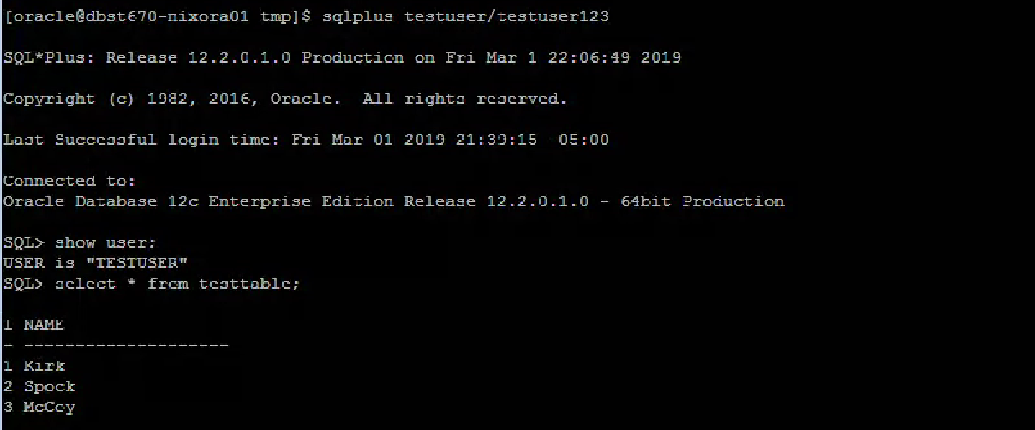

In scenario 4, the test table didn’t exist. So, the table data was back into the database.

* Scenario 5 (Design scenario)

Expdp command used to export the test table.

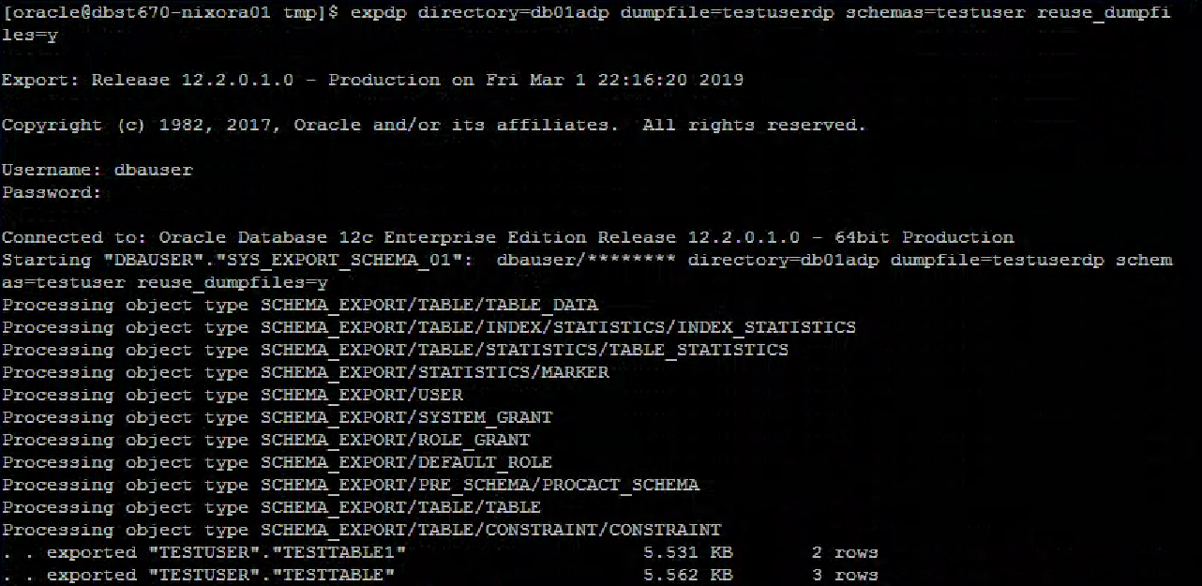

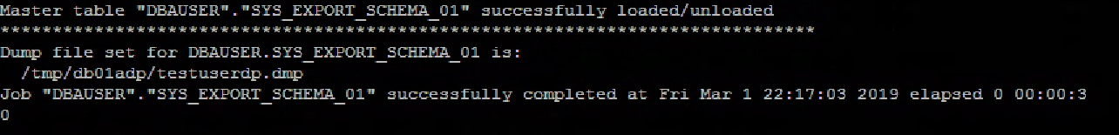

Logged in as test user and dropped the test table.

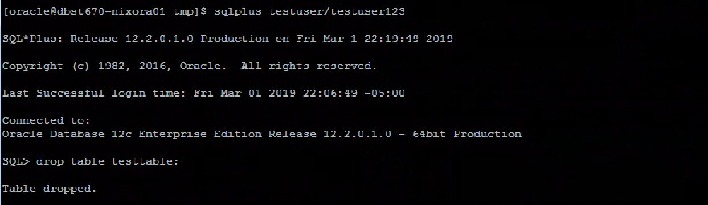

Imported the data into dbauser schema.

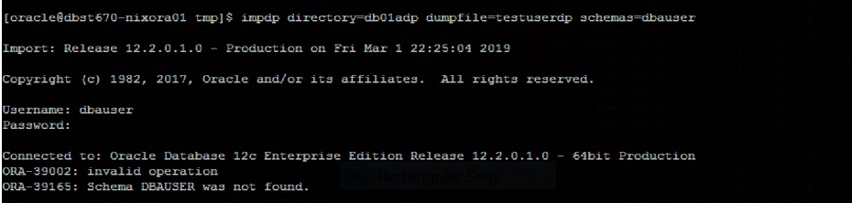

In scenario 5, the impdp command used to import the data under dbauser schema but the process failed and got error message ‘schema dba user was not found.’ To overcome such an issue, we can use REMAP_SCHEMA parameter. This parameter helps to import (load) all objects from the source schema into a target schema.

## **Differences between Original Exp/Imp and Data Pump Exdp/Impdp**

There is a difference between the original **exp/imp and Data pump exdp/impdp. The** normal export/imp operates on a single file whereas Data pump operates on a group of files called dump file sets. Also, Data Pump needs you to create directories for the datafiles and log files. The directory must be created in the database and the user who will export or import Data Pump must have read, write privileges on the directory. Data Pump is much faster than the original exp/imp and enhances performance. In Data Pump, you can also use important parameters like TABLE_EXISTS_ACTION, REMAP_SCHEMA, REMAP_TABLESPACE, etc.

## **Export/Import on Secure Online Shopping System**

First run the export command: “exp owner=DataDesignLeadUser file=DataDesignLeadUser.exp statistics = none:”

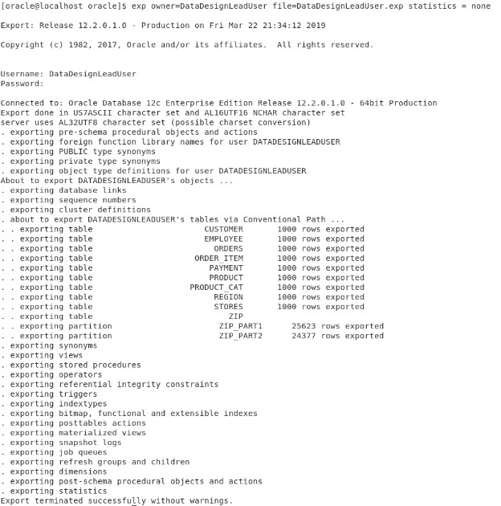

Return to the script and drop the tables and indexes:

SQL>

SQL> SET SERVEROUTPUT ON;

SQL>

SQL> /*---------------------------------------------------*/

SQL> /* DROP INDEXES and TABLES for Export/Import */

SQL> /*---------------------------------------------------*/

SQL>

SQL> SHOW USER;

USER is "DATADESIGNLEADUSER"

SQL>

SQL> CONNECT DataDesignLeadUser/abc123;

Connected.

SQL>

SQL> SHOW USER;

USER is "DATADESIGNLEADUSER"

SQL>

SQL> /*Drop Indexes*/

SQL>

SQL> DROP INDEX fk_zip;

Index FK_ZIP dropped.

SQL>

SQL> DROP INDEX fk_customerid;

Index FK_CUSTOMERID dropped.

SQL>

SQL> DROP INDEX fk_order_id1;

Index FK_ORDER_ID1 dropped.

SQL>

SQL> DROP INDEX fk_product_id;

Index FK_PRODUCT_ID dropped.

SQL>

SQL> DROP INDEX fk_order_id2;

Index FK_ORDER_ID2 dropped.

SQL>

SQL> DROP INDEX fk_emp_storeid;

Index FK_EMP_STOREID dropped.

SQL>

SQL> DROP INDEX fk_emp_zip;

Index FK_EMP_ZIP dropped.

SQL>

SQL> DROP INDEX fk_store_region;

Index FK_STORE_REGION dropped.

SQL>

SQL> DROP INDEX fk_store_zip;

Index FK_STORE_ZIP dropped.

SQL>

SQL> DROP INDEX fk_prodcatid;

Index FK_PRODCATID dropped.

SQL>

SQL> DROP INDEX fk_emp_ssn;

Index FK_EMP_SSN dropped.

SQL>

SQL> /*Drop Tables*/

SQL>

SQL> DROP TABLE payment;

Table PAYMENT dropped.

SQL>

SQL> DROP TABLE order_item;

Table ORDER_ITEM dropped.

SQL>

SQL> DROP TABLE orders;

Table ORDERS dropped.

SQL>

SQL> DROP TABLE product;

Table PRODUCT dropped.

SQL>

SQL> DROP TABLE customer;

Table CUSTOMER dropped.

SQL>

SQL> DROP TABLE employee;

Table EMPLOYEE dropped.

SQL>

SQL> DROP TABLE stores;

Table STORES dropped.

SQL>

SQL> DROP TABLE zip;

Table ZIP dropped.

SQL>

SQL> DROP TABLE region;

Table REGION dropped.

SQL>

SQL> DROP TABLE product_cat;

Table PRODUCT_CAT dropped.

Connection created by CONNECT script command disconnected

Now, we can run the import command: “imp file=DataDesignLeadUser.exp fromuser=DataDesignLeadUser touser=DataDesignLeadUser:”

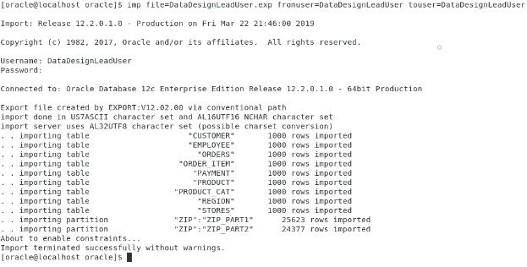

Now, check the row count of each table to verify the data has been imported:

SQL> /*Verify Data is loaded */

SQL>

SQL> SELECT COUNT(*)

2 FROM customer;

COUNT(*)

----------

1000

SQL>

SQL> SELECT COUNT(*)

2 FROM employee;

COUNT(*)

----------

1000

SQL>

SQL> SELECT COUNT(*)

2 FROM order_item;

COUNT(*)

----------

1000

SQL>

SQL> SELECT COUNT(*)

2 FROM orders;

COUNT(*)

----------

1000

SQL>

SQL> SELECT COUNT(*)

2 FROM payment;

COUNT(*)

----------

1000

SQL>

SQL> SELECT COUNT(*)

2 FROM product;

COUNT(*)

----------

1000

SQL>

SQL> SELECT COUNT(*)

2 FROM product_cat;

COUNT(*)

----------

1000

SQL>

SQL> SELECT COUNT(*)

2 FROM region;

COUNT(*)

----------

1000

SQL>

SQL> SELECT COUNT(*)

2 FROM stores;

COUNT(*)

----------

1000

SQL>

SQL> SELECT COUNT(*)

2 FROM zip;

COUNT(*)

----------

50000

# SQL Control File Loaders

## **Load Data**

SQL>

SQL>

SQL> /*Go to Console and Run the "RunSQLLoaders" file - Loads data into tables*/

Customer.ctl

OPTIONS (SKIP=3, LOAD=1000)

LOAD

INFILE customer.dat

REPLACE INTO TABLE customer

FIELDS TERMINATED BY ',' OPTIONALLY ENCLOSED BY '"'

(

CUSTOMERID

,FIRSTNAME

,LASTNAME

,PHONENO

,ADDRESS

,ZIPCODE

)

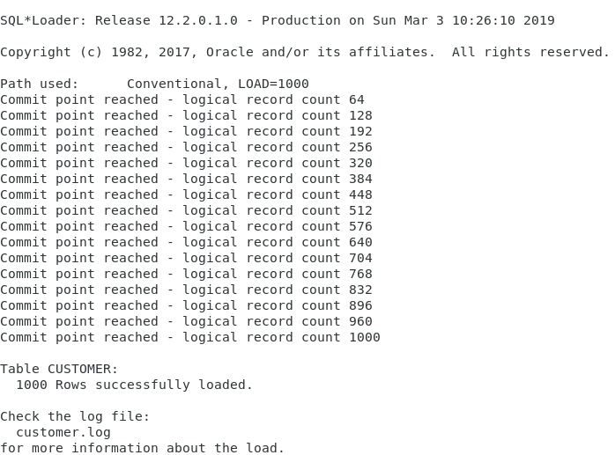

Employee.ctl

OPTIONS(LOAD=1000)

LOAD

INFILE 'DBST670_Employee.csv'

REPLACE

INTO TABLE employee

FIELDS TERMINATED BY ","

(SALES_EMP_SSN, STOREID,FIRSTNAME,LASTNAME, ADDRESS, PHONENO, ZIPCODE)

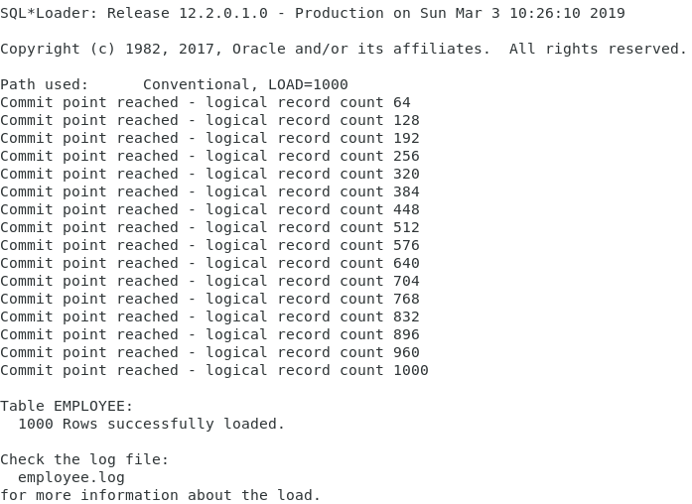

Order_item.ctl

OPTIONS (SKIP=2, LOAD=1000)

LOAD DATA

INFILE 'order_item.dat'

INTO TABLE order_item

(ORDERID TERMINATED BY WHITESPACE,

PRODUCTID TERMINATED BY WHITESPACE,

QUANTITY TERMINATED BY WHITESPACE)

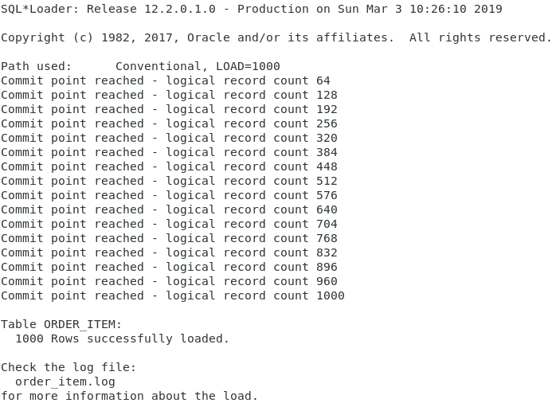

Orders.ctl

OPTIONS (SKIP=3, LOAD=1000)

LOAD DATA

INFILE 'order.dat'

REPLACE

INTO TABLE orders

(ORDERID TERMINATED BY WHITESPACE,

CUSTOMERID TERMINATED BY WHITESPACE,

SALES_EMP_SSN TERMINATED BY WHITESPACE,

ORDER_METHOD TERMINATED BY WHITESPACE

)

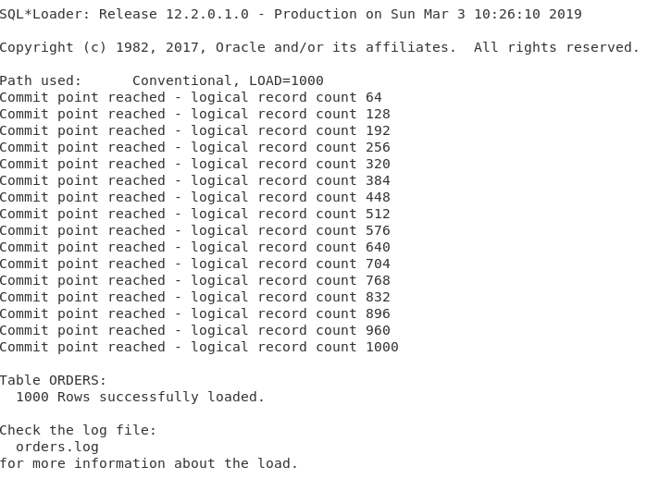

Payment.ctl

OPTIONS (SKIP=3, LOAD=1000)

LOAD DATA

INFILE payment.dat

INTO TABLE payment

FIELDS TERMINATED BY ","

(PAYMENTID,ORDERID,CARD_EXP_DATE,CARD_NUMBER,PAYMENT_AMOUNT,PAYMENT_METHOD)

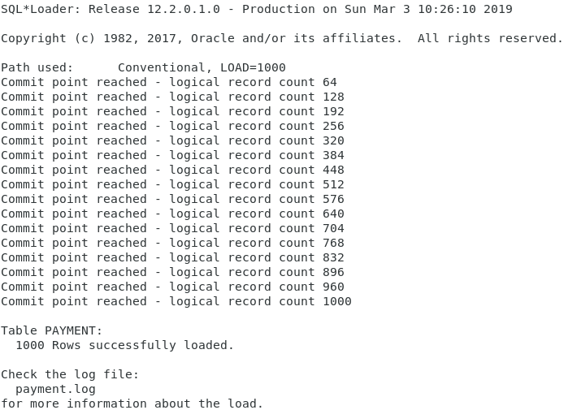

Product.ctl

OPTIONS(SKIP=3, LOAD=1000)

LOAD

INFILE 'product.dat'

REPLACE

INTO TABLE product

(PRODUCTID TERMINATED BY WHITESPACE,

PROD_UNIT_PRICE TERMINATED BY WHITESPACE,

DESCRIPTION TERMINATED BY WHITESPACE)

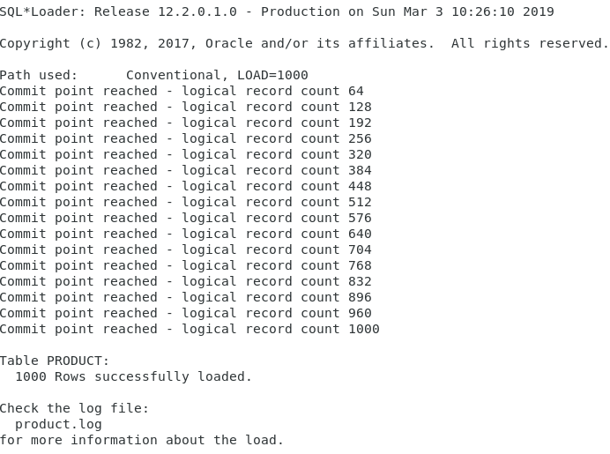

Productcat.ctl

OPTIONS(LOAD=1000)

LOAD

INFILE 'DBST670_Product_Cat.csv'

REPLACE

INTO TABLE product_cat

FIELDS TERMINATED BY ","

(PRODCATID ,PRODCATTYPE, DESCRIPTION)

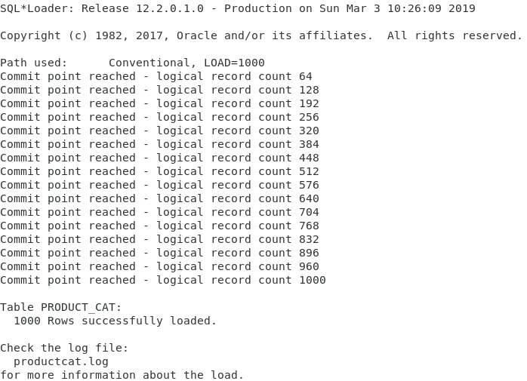

Region.ctl

OPTIONS(LOAD=1000)

LOAD

INFILE 'DBST670_Region.csv'

REPLACE

INTO TABLE region

FIELDS TERMINATED BY ","

(REGIONID,REGIONNAME,DESCRIPTION)

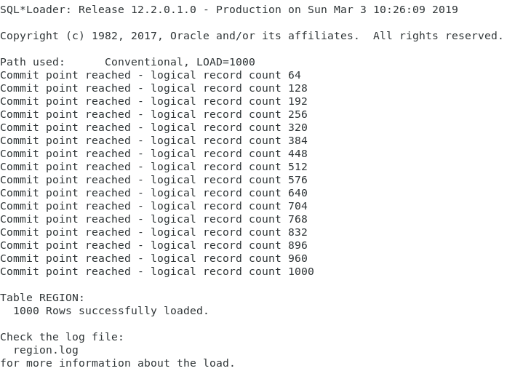

Stores.ctl

OPTIONS(LOAD=1000)

LOAD

INFILE 'DBST670_Store.csv'

REPLACE

INTO TABLE stores

FIELDS TERMINATED BY ","

(STOREID,REGIONID, STORENAME,ADDRESS, PHONENO, ZIPCODE)

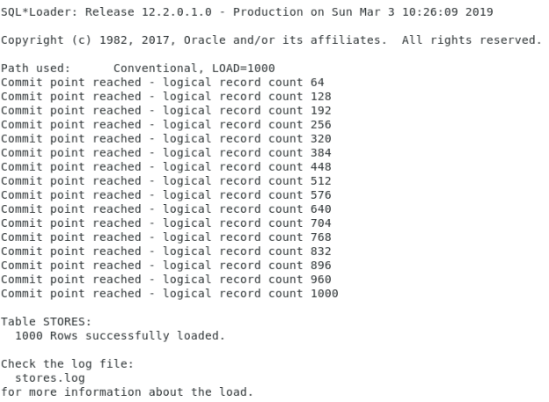

Zip.ctl

OPTIONS (SKIP=2, LOAD=50000)

LOAD DATA

INFILE hb_zip.dat

INTO TABLE zip

(

ZIPCODE POSITION(01:10) ,

CITY POSITION(11:25) ,

STATE POSITION(26:27)

)

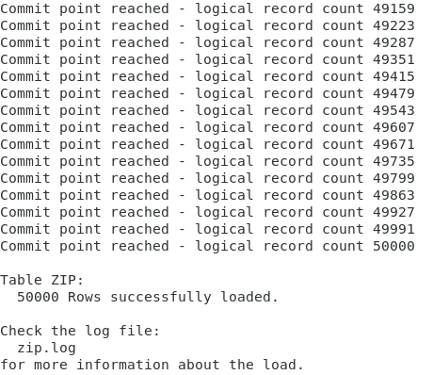

SQL> /*Fill gaps from Loader*/

SQL> /*Product table needs PRODCATID from Product_Cat table*/

SQL>

SQL> UPDATE product t1

2 SET

3 t1.prodcatid = (

4 SELECT prodcatid

5 FROM product_cat t2

6 WHERE t2.prodcatid = t1.productid

7 )

8 WHERE EXISTS (

9 SELECT NULL

10 FROM product_cat t2

11 WHERE t2.prodcatid = t1.productid

12 );

1,000 rows updated.

## **Query Tables**

SQL>

SQL> /*Verify Data is loaded */

SQL> SELECT * FROM customer;

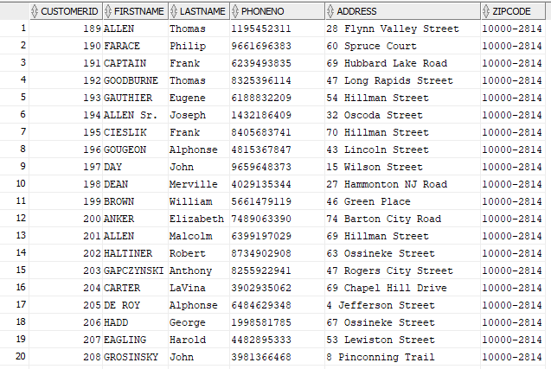

SQL> SELECT * FROM employee;

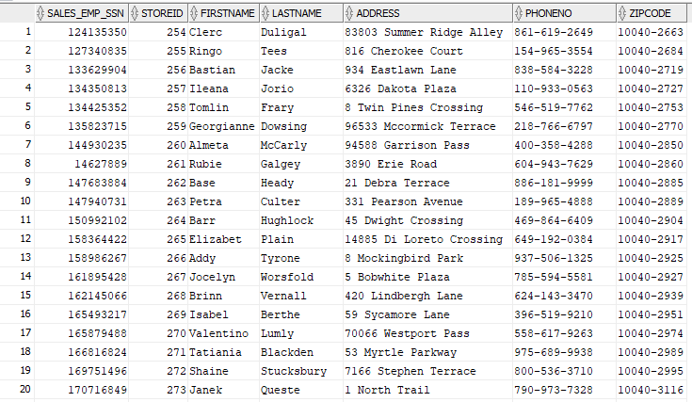

SQL> SELECT * FROM order_item;

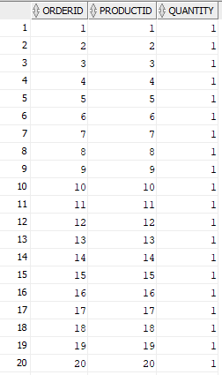

SQL>

SQL> SELECT * FROM orders;

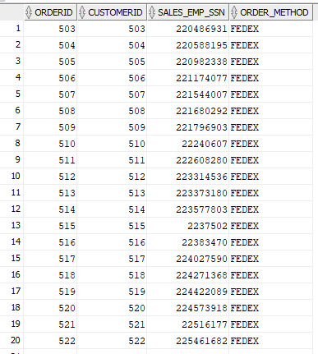

SQL>

SQL> SELECT * FROM payment;

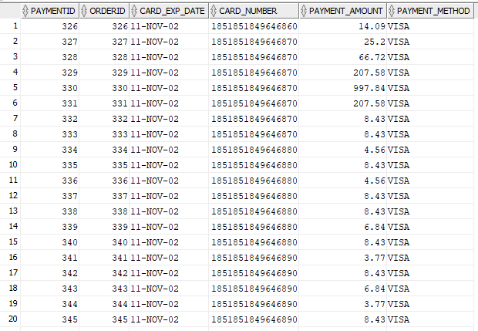

SQL>

SQL> SELECT * FROM product;

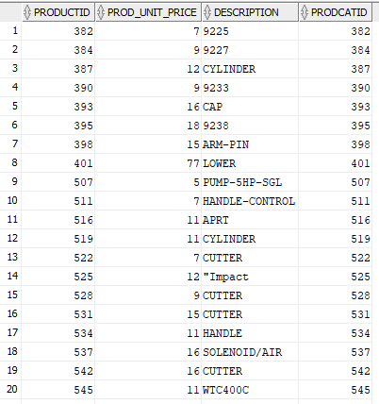

SQL>

SQL> SELECT * FROM product_cat;

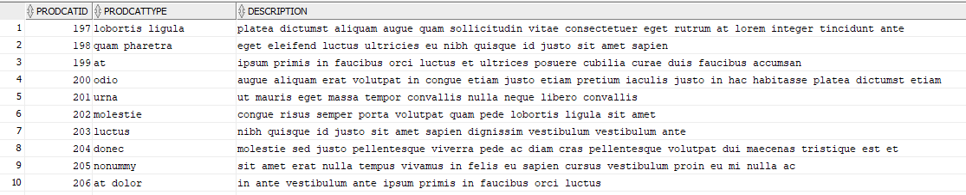

SQL>

SQL> SELECT * FROM region;

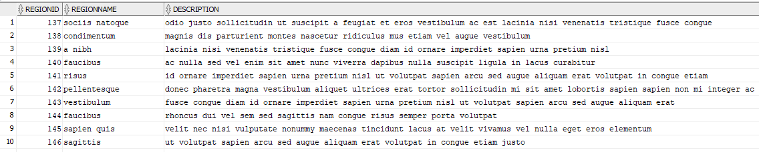

SQL>

SQL> SELECT * FROM stores;

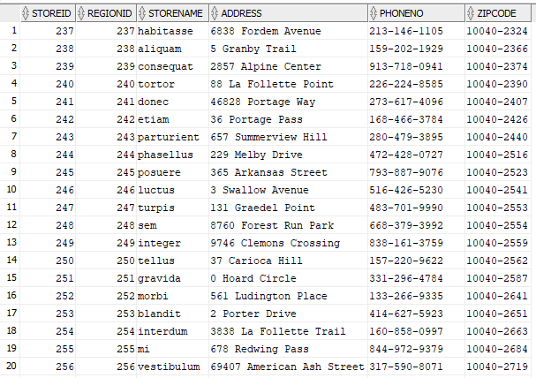

SQL>

SQL> SELECT * FROM zip;

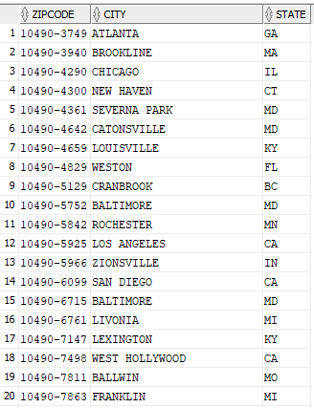

# Analyze Tables

SQL>

SQL> /*---------------------------------------------*/

SQL> /* ANALYZE TABLES */

SQL> /*---------------------------------------------*/

SQL>

SQL> /*Analyze with deprecated command*/

SQL>

SQL> ANALYZE TABLE customer COMPUTE STATISTICS;

Table CUSTOMER analyzed.

SQL> ANALYZE TABLE employee COMPUTE STATISTICS;

Table EMPLOYEE analyzed.

SQL> ANALYZE TABLE order_item COMPUTE STATISTICS;

Table ORDER_ITEM analyzed.

SQL> ANALYZE TABLE orders COMPUTE STATISTICS;

Table ORDERS analyzed.

SQL> ANALYZE TABLE payment COMPUTE STATISTICS;

Table PAYMENT analyzed.

SQL> ANALYZE TABLE product COMPUTE STATISTICS;

Table PRODUCT analyzed.

SQL> ANALYZE TABLE product_cat COMPUTE STATISTICS;

Table PRODUCT_CAT analyzed.

SQL> ANALYZE TABLE region COMPUTE STATISTICS;

Table REGION analyzed.

SQL> ANALYZE TABLE stores COMPUTE STATISTICS;

Table STORES analyzed.

SQL> ANALYZE TABLE zip COMPUTE STATISTICS;

Table ZIP analyzed.

SQL>

SQL> /*Check results*/

SQL>

SQL> SELECT num_rows, blocks, empty_blocks, avg_space, avg_row_len

2 FROM user_tables

3 WHERE table_name ='CUSTOMER'

4 OR table_name = 'EMPLOYEE'

5 OR table_name = 'ORDER_ITEM'

6 OR table_name = 'ORDERS'

7 OR table_name = 'PAYMENT'

8 OR table_name = 'PRODUCT'

9 OR table_name = 'PRODUCT_CAT'

10 OR table_name = 'REGION'

11 OR table_name = 'STORES'

12 OR table_name = 'ZIP';

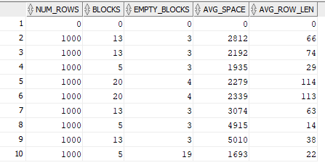

SQL>

SQL>

SQL> /*Remove gathered statistics*/

SQL>

SQL> ANALYZE TABLE customer DELETE STATISTICS;

Table CUSTOMER analyzed.

SQL> ANALYZE TABLE employee DELETE STATISTICS;

Table EMPLOYEE analyzed.

SQL> ANALYZE TABLE order_item DELETE STATISTICS;

Table ORDER_ITEM analyzed.

SQL> ANALYZE TABLE orders DELETE STATISTICS;

Table ORDERS analyzed.

SQL> ANALYZE TABLE payment DELETE STATISTICS;

Table PAYMENT analyzed.

SQL> ANALYZE TABLE product DELETE STATISTICS;

Table PRODUCT analyzed.

SQL> ANALYZE TABLE product_cat DELETE STATISTICS;

Table PRODUCT_CAT analyzed.

SQL> ANALYZE TABLE region DELETE STATISTICS;

Table REGION analyzed.

SQL> ANALYZE TABLE stores DELETE STATISTICS;

Table STORES analyzed.

SQL> ANALYZE TABLE zip DELETE STATISTICS;

Table ZIP analyzed.

SQL>

SQL> /*Run DBMS_STATS to get all stats*/

SQL>

SQL> EXEC DBMS_STATS.gather_schema_stats(ownname => 'DATADESIGNLEADUSER');

PL/SQL procedure successfully completed.

SQL>

SQL> /*Check results*/

SQL>

SQL> SELECT num_rows, blocks, empty_blocks, avg_space, avg_row_len

2 FROM user_tables

3 WHERE table_name ='CUSTOMER'

4 OR table_name = 'EMPLOYEE'

5 OR table_name = 'ORDER_ITEM'

6 OR table_name = 'ORDERS'

7 OR table_name = 'PAYMENT'

8 OR table_name = 'PRODUCT'

9 OR table_name = 'PRODUCT_CAT'

10 OR table_name = 'REGION'

11 OR table_name = 'STORES'

12 OR table_name = 'ZIP';

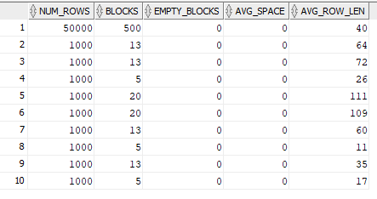

# Query Row Numbers from Catalog

SQL>

SQL> /*Query row numbers from catalog*/

SQL>

SQL> SELECT table_name,

2 num_rows,

3 owner

4 FROM all_tables

5 WHERE owner = 'DATADESIGNLEADUSER'

6 ORDER BY owner,

7 table_name;

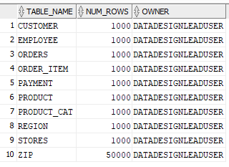

SQL>

SQL> COMMIT;

Commit complete.

# References

Barbradozier. (2013). Barbra Dozier's Blog. Retrieved from Wordpress: https://barbradozier.wordpress.com/2013/07/25/online-shopping-system/

Maxim, B. R. (2012). Requirements analysis. Retrieved from Slideshare: https://www.slideshare.net/asimnawaz54/requirements-analysis-15191479

Requirements Analysis Techniques with Example: Complete Tutorial. (2019). Retrieved from Guru99: https://www.guru99.com/requirements-analysis-and-transformation-techniques.html

Rouse, M. (2019). Requirements Analysis. Retrieved from TechTarget: https://searchsoftwarequality.techtarget.com/definition/requirements-analysis

Sofia. (2010). Software Development Process: Requirements Analysis. Retrieved from https://www.uacg.bg/filebank/acadstaff/userfiles/publ_bg_397_SDP_activities_and_steps.pdf